**Champion CSA Screening Methodology**

**Dec 2016**

**Authors**

**Kiran P. Bhatta, PhD**

Monitoring and Evaluation Expert, LI-BIRD

**Bikash Paudel, PhD**

Senior Program Manager, LI-BIRD

**Pashupati Chaudhary, PhD**

Program Development Director, LI-BIRD

**Arun Khatri-Chhetri, PhD**

Socio-Economist, CCAFS-SA

**Ram B. Rana, PhD**

Program Operations Director, LI-BIRD

**Puna Bhaila**

Research Officer, LI-BIRD

This document is an output from a project commissioned through the Climate and Development Knowledge Network (CDKN). CDKN is a program funded by the UK Department for International Development (DFID) and the Netherlands Directorate General for International Cooperation (DGIS) for the benefit of developing countries. The views expressed and information contained in it are not necessarily those of or endorsed by DFID, DGIS or the entities managing the delivery of the CDKN, which can accept no responsibility or liability for such views, completeness or accuracy of the information or for any reliance placed on them.

**Citation for this report**

Bhatta, K. P., B. Paudel, P. Chaudhary, A. Khatri-Chhetri, R. B. Rana, and P. Bhaila. 2016. Scaling-up Climate Smart Agriculture in Nepal – Champion CSA Screening Methodology. Local Initiatives for Biodiversity, Research, and Development (LI-BIRD) and The Consultative Group for International Agricultural Research’s (CGIAR) Research Program on Climate Change, Agriculture, and Food Security (CCAFS), Kaski, Nepal.

**For further details, please contact:**

Kiran P. Bhatta, PhD

Monitoring and Evaluation Expert

LI-BIRD, Kaski, Nepal

Email: kiran.bhatta@libird.org

Telephone: (++977)-61-535357

**First Draft Submitted on:** November 15, 2016

# Acknowledgement

First of all, the authors would like to thank CDKN for funding the CSA project, through which this study is convened.

Authors would also like to appreciate researchers/scientists from CGIAR’s Research Program on CCAFS and LI-BIRD for their comments/suggestions provided throughout different stages of writing this report. Authors would specifically like to thank Dr. Balaram Thapa (LI-BIRD); Dr. Pramod Aggarwal, Dr. Tek B. Sapkota, and Dr. Paresh Shirsath (CCAFS); and Dr. Ram Chandra Khanal (CDKN) for their support at various stages during the write-ups and methodology development.

The field officers/assistants of CSA project provided various information useful for this study and hence their efforts are acknowledged. The authors would specifically like to mention the contribution from the following: Ms. Aastha Bhusal, Ms. Puna Bhaila, Ms. Rita gurung, Ms. Ima K. Tamang, Mr. Kartik L. Chaudhary, and Mr. Tanka P. Dhungana. The authors would like to thank all the data enumerators for their support in data collection.

The authors would also like to thank all others for supporting directly or indirectly in this research/study. However, authors take full responsibility for all errors/mistakes and limitations of this study.

# Abbreviations

CSA Climate Smart Agriculture

GDP Gross Domestic Product

CCAFS Climate Change, Agriculture and Food Security

LI-BIRD Local Initiatives for Biodiversity, Research and Development

CDKN Climate and Development Knowledge Network

CGIAR Consultative Group on International Agricultural Research

GESI Gender Equality and Social Inclusion

FGD Focus Group Discussion

KII Key Informant Interview

WTP Willingness to Pay

AHP Analytic Hierarchy Process

VDC Village Development Committee

GoN Government of Nepal

INGOs International Non-Government Organizations

NGOs Non-Governmental Organizations

IRD Informal Research and Development

SRI System of Rice Intensification

NUS Neglected and Under-Utilized (Crop) Species

ICT Information Communication Technology

MUS Multi-water Use System

CAMC Conservation Area Management Committee

VC4 Village Climate Change Coordination Committee

BCDC Biodiversity Conservation and Development Committee

ASC Agricultural Service Center

LSC Livestock Service Center

DDC District Development Committee (Office)

DADO District Agricultural Development Office

DSCO District Soil Conservation Office

DLSO District Livestock Service Office

PAC Project Advisory Committee

# Content

Acknowledgement i

Abbreviations ii

Content iii

List of Tables iv

List of Figures v

List of Annexes vi

Executive Summary vii

1. Introduction and Background 1

2. CSA Screening Methodology 2

Selection of potential CSAs for Study 3

Documentation of Evidences 4

Criteria and Indicators for Evaluation 4

Methods for documenting evidences 5

Consolidation of Results for Finalizing Champion CSA 12

Validation and Finalization 14

3. Conclusion and Recommendation 15

4. References 17

5. Annexes 18

# List of Tables

Table 1: Technologies piloted by the project in different Agro-Ecological Zones 4

Table 2: List of on-farm trials which provided information for selection of Champion CSAs 6

Table 3: Type of data recorded from piloting of CSA technologies 8

Table 4: Events Utilized for Taking Stakeholders' Feedback 10

Table 5: Technologies and practices selected for evaluation (study) * 12

Table 6: Changes brought by CSAs implementation in Agyouli, Nawalparasi 14

Table 7: Changes brought by CSAs implementation in Majhthana, Kaski 15

Table 8: Changes brought by CSAs implementation in Ghanpokhara, Lamjung 16

Table 9: Champion CSA technologies and practices 13

# List of Figures

Figure 1: Overview of Champion CSA Screening Methodology 2

Figure 2: Criteria for defining CSA 5

Figure 3: Indicators of CSA 5

Figure 4: Scores of three pillars and GESI compared by gender and study sites 18

Figure 5: Prioritization of CSAs by females and males in Ghanpokhara, Lamjung 10

Figure 6: Prioritization of CSAs by females and males in Majhthana, Kaski 10

Figure 7: Prioritization of CSAs by females and males in Agyouli, Nawalparasi 11

# List of Annexes

|  |  |
| --- | --- |
| Annex 1: CSA technologies/practices tested and validated by different organizations working in Nepal ……………………………………………………………………………………………………………………………. | 18 |
| Annex 2: Household Survey Questionnaire …………………………………………………………………………………… | 19 |
| Annex 3: Results from Household Survey (Ghanpokhara, Lamjung)……………………………………………….. | 26 |
| Annex 4: Results from Household Survey (Majhthana, Kaski) ……………………………………………………….. | 30 |
| Annex 5: Results from Household Survey (Agyouli, Nawalparasi) …………………………………………………. | 34 |
| Annex 6: Analytic Hierarchy Process for Multi-Criteria Analysis ………………………………………………….. | 38 |
| Annex 7: AHP Questionnaire …………………………………………………………………………………………………..……. | 40 |

# Executive Summary

This report highlights the part C of the Climate-Smart Agriculture (CSA) methodology report that comprise (part A) Identification and prioritization of potential CSAs, (part B) Piloting, testing and validation of promising CSAs, and (part C) Selection of champion CSAs, and (D) Extrapolation of CSA scaling up options across Nepal. The methodology for part A, B and C has been reported in “Technology Identification and Piloting Methodology Report”.

The selection of champion CSAs involves the following steps: (I) Selection of potential CSAs for evaluation, (II) documenting evidences, (III) consolidation of results, and (IV) validation and finalization of champion CSAs. The selection of the potential CSAs for evaluation is based on the ‘CSA screening process’ where CSAs are screened by experts regarding its qualification as CSA, and by farmers regarding its suitability to address local climatic vulnerability and feasibility. In this study, evidences gathered through various methods such as on-farm experimentation, data recorded during piloting, collection of stakeholder opinion, key informant survey, household surveys to evaluate the effect of CSA implementation, and analytical hierarchy process (AHP) to evaluate farmers’ preference has been used to evaluate and compare CSAs. The final list of champion CSAs was prepared using ‘expert’s judgement’ based on the data and results obtained from different evaluation methods. This was validated by local communities and district level stakeholders through field observations, interactions, and Focus Group Discussions (FGDs). Feedbacks were collected from national level stakeholders through sharing of document for review, invitation to field for direct observation and a national level workshop.

The results shows that farmers, irrespective of place and gender, provide overwhelmingly high importance to ‘food security’ and low importance to gender equity and social inclusion (GESI) dimensions while selecting the CSA options. The final list of champion CSAs constitutes 17 CSAs or package of CSAs for Nepal. Among them, nine CSAs are champion for high-hill region, 12 CSAs are for mid-hill region and 10 CSAs are for Terai region. Six CSAs from the list are champions for all three agro-ecological regions. The scaling up of these champion CSAs would greatly contribute to build resilient agriculture systems in all agro-ecological regions.

Combined with ‘CSA Identification and Piloting Methodology Report’ submitted earlier, this ‘Champion Screening Methodology Report’ provides a complete framework to identify, prioritize, pilot, and evaluate the champion CSAs. The pillars/themes developed to define CSA for Nepal, criteria constructed for different pillars/themes, and indicators identified for each criteria; constitutes contribution to the art of knowledge for CSA discourse in Nepal and worldwide. The methodology developed in Nepal can be applied everywhere, although the CSA pillars, criteria and indicators may vary by location and conditions.

# 1. Introduction and Background

Nepalese agriculture is highly vulnerable to climate change due to high exposure to climatic hazards. It is also highly sensitive due to its overdependence on climate. But the adaptive capacity of people is too low owing to high poverty levels and less capacity for capital generation (MoE, 2011). Climate change is already having its toll on livelihood assets and livelihoods, and is expected to exacerbate in the future. Although future impacts of climate change on production and productivity of the three key crops of rice, maize, and wheat shows different patterns of changes over time and across agro-ecological regions, the net annual agricultural loss by 2070 is likely to be around 0.8 percent of the current GDP equivalent (IDS–Nepal, PAC, and GCAP, 2014). Therefore, current and future agricultural development in Nepal need to be responsive to the current as well as future climate variability. There is an urgent need to identify and promote agriculture technologies and practices that can contribute to achieving the country’s food security goal by increasing productivity, providing options for smallholder farmers to adapt to climatic variabilities, and, if possible, contribute to achieve national mitigation targets. Promotion of Climate Smart Agriculture (CSA) could be the way forward for Nepalese agriculture development since it gives a framework for reconciling adaptation to climate change, enhancing crop production and national food security, and promoting mitigation in agriculture.

In response to this situation in Nepal, project entitled “Scaling-Up of Climate Smart Agriculture in Nepal” (hereafter the CSA project) is being implemented by Local Initiatives for Biodiversity, Research and Development (LI-BIRD) and CGIAR’s Research Program on Climate Change, Agriculture and Food Security (CCAFS), with funding support from the Climate and Development Knowledge Network (CDKN). The project aims to develop portfolios of champion CSA technologies and practices for different agro-ecological zones of Nepal; assess challenges, strategies and key enabling factors for scaling-up CSA; and develop scaling-up pathways and implementation plans for CSAs to contribute to climate change adaptation in agriculture systems, ultimately targeting to reduce the vulnerability of women and poor farmers of Nepal that encompasses the majority of farming community of the country.

Several steps of analysis has to be conducted to be able to recommend champion CSAs for a given condition. Firstly, potential CSAs are identified through various means such as previous experiences of the institutions, literature review, stakeholder consultations etc. After that, CSAs need to be put under first-level of screening for finding out its suitability for given agro-ecological zone. The potential CSAs, then undergo piloting and verification for finding out their practical suitability at the given location under given set of conditions. The methodology up to this stage of CSA evaluation has been covered in the previous methodology report, namely, “Technology Identification and Piloting Methodology Report” (Bhatta et al., 2016). The focus of the report was on identification and screening of technologies based on theoretical set of criteria developed by the project. After the CSAs obtained through first level of screening (theoretical methodology) have undergone field piloting, this report outlines the methodologies for selection of champion CSAs among the potential CSAs. This report highlights the methods and tools that are useful to evaluate the appropriateness and/or suitability of CSAs based on evaluation conducted through the use of different indicators developed by the project.

# 2. Champion CSA Screening Methodology

Given the limited resources, every country needs to find out the priority areas for investment. Although, there can be many CSAs suitable for different agro-ecological regions of Nepal, it is essential to identify and invest for those technologies that are very cost effective. The set of CSAs which are best feasible for different agro-ecological regions and provide highest gain in term of resilience to climate change can be termed as Champion CSAs. The main deliverable of the CSA project is the scaling-up pathways for the selected champion CSAs. For the selection of the champion CSAs, a rigorous 4-step method was adopted.

The first step in the champion CSA screening methodology was selection of those CSAs which merits further analysis, more simply, identification of the initial list of CSAs which will undergo further evaluation. This is followed by rigorous process of creating and documenting the evidences from various data sources, new data collection and analysis. The third step in the process is consolidating the results of various analysis and selection of champion CSAs. The fourth and final step is validation of the champion CSA list from various stakeholders. Since the first step of the process (i.e. selection of potential CSAs) has been described in the first methodology report in detail, this report will briefly present the first step. Further, this report will discuss the other steps of the Champion CSA Screening Methodology, with details of the tools and methods used for the analysis, results of the analysis and key learnings during application of those methods. The steps followed for champion screening can be highlighted as in Figure 1:

**Selection of potential CSAs for Study**

**Documenting the evidences**

**Consolidating the results**

**Validation and finalization**

Figure 1: Overview of Champion CSA Screening Methodology

The final output of the process is selection of the champion CSAs for three agro-ecological regions of Nepal. With the generated evidence from field, the possible impact of scaling-up of selected champion CSAs will be evaluated through extrapolation. Later, a pathways for scaling-up will be developed along with the implementation plan and financing mechanism for scaling-up champion CSAs. The following sub-sections elaborates the process in detail.

**STEP I**

## SELECTION OF POTENTIAL CSAS

These methodologies followed the CSA identification and prioritization methods described in detail in the previous methodology report titled “Technology Identification and Piloting Methodology Report” (Bhatta et al., 2016a). The brief steps for the selection of potential CSAs are outlined below:

* The process began with the creation of a pool of possible CSA technologies and practices from various sources including literature review; learnings from the experience of LI-BIRD, CCAFS, and other organizations; interaction with government, non-government, and private sector agencies; and documentation of local adaptation practices innovated by farmers.
* After creation of the pool of CSAs, these were short listed and prioritized. This was done using a multi-criteria analysis method that employed weighing of CSAs based on a set of criteria developed under the three pillars (Food Security, Climate Change Adaptation, and Mitigation) and a GESI theme and, thereafter, a scoring exercise.
* Among the short-listed CSAs, the CSAs suitable for piloting and demonstration were selected based on farmers’ preference to pilot the technology, technical feasibility of the technology in a particular location, potential of a technology to responding to climate change, and other criteria.

The list of technologies and practices piloted by this project in the field is provided in Table 1. Some of the technologies/practices are not piloted by this project, yet considered for analysis of champion CSAs which is discussed in the subsequent sections.

Table 1: Technologies piloted by the project in different Agro-Ecological Zones

|  |  |  |
| --- | --- | --- |
| **Agyouli (Nawalparasi)** | **Majhthana (Kaski)** | **Ghanpokhara (Lamjung)** |
| Cattle-shed and Manure Management | Bio-engineering | Agro-forestry |
| Home Garden | Cattle-shed and Manure Management | Bio-engineering |
| ICT-based agro-advisory | Community Pond | Cardamom Dryer |
| New crops and varieties | Grain Pro Bag | Cattle-shed and Manure Management |
| Nutrient Management | Green Manuring (Rice) | Home Garden |
| Riverside Protection | ICT-based Agro-advisory | ICT-based agro-advisory |
| Solar-based irrigation | New crops and varieties | New crops and varieties |
| System of Rice Intensification | Nursery | Nursery |
| Zero Tillage Garlic | Plastic House (only) | Plastic House |
| - | Plastic House with Drip Irrigation | Plastic Pond |
| - | Plastic Pond | - |
| - | Stress (Drought) Tolerance (Rice) | - |
| - | Water Source Management / Protection | - |

The selected technologies and practices underwent further evaluation and validation in the form of piloting, on-farm experimentations, and on-farm demonstrations. The location-specific CSA practices were chosen based on assessment of climatic risks to existing agricultural production systems as well as other socio-economic and biophysical vulnerabilities, using a combination of top-down (science-based) and bottom-up (farmers’ perception based) methods.

**STEP II**

## DOCUMENTATION OF EVIDENCES

***Criteria and Indicators for Evaluation***

For Nepalese context, CSA is defined through three main pillars (ability to contribute to food security, ability to contribute to adaptation, and contribute to mitigation, if possible) and potential to enhance condition and position of women and disadvantaged groups (GESI). CSAs are therefore evaluated through 13 criteria which helps to define the pillars. The Figure 2 shows the criteria used to define each pillars and the cross-cutting theme (see “Technology Identification and Piloting Methodology Report” for detail elaboration on these pillars and criteria).

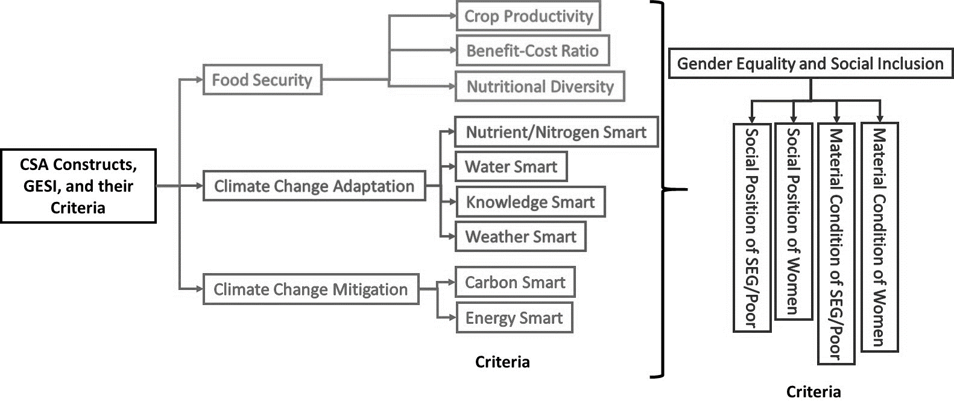

Figure 2: Criteria for defining CSA

For making the evaluation simpler, at least 2 indicators were developed for each of the 13 criteria. While defining the criteria, particular attention was given to make SMART indicators (simple or specific; measurable; achievable or attainable; realistic or relevant; and time-bound). Figure 3 shows the indicators developed for each of the criteria under three pillars and a cross-cutting theme (see “Technology Identification and Piloting Methodology Report” for detail elaboration on indicators).

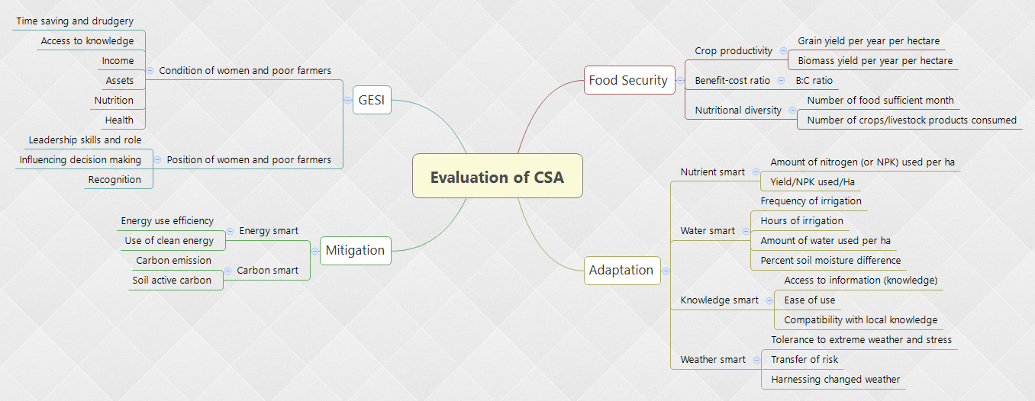

Figure 3: Indicators of CSA

***Methods used for documenting the evidences***

Various quantitative and qualitative methods were applied to document the evidences regarding performances of CSAs during the project period.

## 

**1. On-Farm Experimentation**

On farm experiments were set-up to evaluate the CSAs which were technically feasible for on-farm evaluation, farmers’ were willing to evaluate the technology in their field, and the results is achievable within project period. In most of the case, new CSAs are implemented together with the farmers’ own practice for making paired comparisons. Eventually, these trials were also useful to demonstrate the benefits of the new CSA to farmers. Before conducting on-fam trials, detail research protocol were developed which included what to investigate, how to investigate, and what data to be recorded. Table (2) shows the CSAs for which on-farm trials were established.

Table 2: List of on-farm trials which provided information for selection of Champion CSAs

|  |  |  |  |  |  |
| --- | --- | --- | --- | --- | --- |
| **SN** | **Trial type** | **Agro-ecology** | **Objective** | **Numbers of trials** | **Remarks** |
| 1 | Zero Tillage Garlic | Terai | Evaluating alternative tillage method for garlic cultivation during water stressed period | 12 |  |
| 2 | Improved FYM | Mid-hill | Evaluating the efficacy of manure received from improved cattle-shed management package | 12 |  |
| 3 | Stress tolerant rice varieties trial | Mid-hill | Evaluating the best stress (drought) tolerance rice variety for mid-hill region | 1 |  |
| 4 | Green manuring | Mid-hill | Evaluate the effect of green manuring on rice (Ekle Dhan: a local rice variety) | 1 |  |
| 5 | SRI on rice | Terai | Evaluate the benefits and costs of SRI practice on rice | 3 | Since the trials were established in 2016 season, the data are yet to come |
| 6 | Nutrition management on rice | Terai | Evaluate the benefits of precision nutrition management in comparison to farmers’ practice | 3 | Since the trials were established in 2016 season, the data are yet to come |
| 7 | Crop establishment trials for maize | Terai and hills | Evaluate the performance of Jap Planter for maize | 2 |  |
| 8 | Nutrient management trial for maize | Terai and hills | Evaluate the benefits of precisions nutrition management (nutrient expert tool) in comparison to farmers’ practice | 3 |  |

Due to the short project period, quantitative data collected from household surveys and qualitative data generated through focus group discussions with farmers (the ultimate beneficiaries and the one who will decide on adoption/rejection of any of the potential CSA technologies and practices) and stakeholders are used for evaluation of champion CSAs. Besides, due to difference in the nature of technologies, quantitative on-farm trial data could not be used for conducting the universal comparison of all CSAs. Therefore, the results of the on-farm trials has been used in final evaluation of the CSAs as evidences, and the results have been reported as separate case studies.

**2. Data recording during piloting of CSAs**

While some CSAs were put under on-farm experimentation for validation, some others were piloted on farmers’ field. Project supported certain percentage of the initial investment cost of implementing CSAs for piloting purpose. The objective of piloting of CSA technology was to demonstrate the benefits of adoption to farmers, and if required, refine, revise and improve the CSA from the feedbacks received during the implementation. Various quantitative and qualitative information were recorded during the piloting of the CSAs. Again, due to short research duration and diversity of the CSAs, the information recorded during pilots are not easily comparable among CSAs. However, the costs of implementation (investment cost and recurring costs) as well as benefits received by farmers in one-season can, theoretically, be compared. However, comparison of the one-season benefits can lead to false conclusion, particularly for those technologies which provides long-term and sustained benefits (e.g. solar-based irrigation). Therefore, this data was also used as evidence to provide basis for ratings on the CSA criteria but not universally compared.

Table 3: Type of data recorded from piloting of CSA technologies

|  |  |  |
| --- | --- | --- |
| **CSAs** | **Locations** | **Type of recorded data** |
| Solar-based irrigation | Nawalparasi | Installation cost, potential benefits |
| Plastic house, plastic pond, drip irrigation | Kaski, Lamjung | Construction cost, one-season benefits |
| Community pond | Lamjung | Construction cost, potential benefits |
| Improved farm yard manure, cardamom drier, bio-engineering, agro-forestry, riverside protection | Kaski, Lamjung, Nawalparasi | One time investment cost |
| ICT based agro-advisory, new crops and new varieties, grain-pro bags, improved home garden | Kaski, Lamjung, Nawalparasi | Recurring cost |

**3. Collecting Stakeholders’ Opinion**

Majority of the investment required for scaling-up CSAs in Nepal is likely to come from government agencies, farmers’, local institutions, development partners and private sectors. Therefore, emphasis was given to strategically collect the opinion and feedback of these stakeholders during selection of champion CSAs. This step was crucial for selection of CSAs at the beginning, and this process was continued throughout the piloting period.

The views and opinions of different stakeholders were incorporated during selection of champion CSAs. Multiple visits from local level stakeholders (e.g. officials from District Agriculture Development Office), a visit from National Planning Commission Team including honorable member and the Joint-Secretary, two field visit from multi-sectoral Project Advisory Committee members (including officers from seven different ministries and departments), were some of the opportunities for gathering views and opinions from policy makers to integrate national priorities into the process of champion CSA selection. These events were also successful to build the agreement among the stakeholders regarding what types of CSAs should be prioritized for different agro-ecological conditions. Besides, project organized a national ‘learning-sharing workshop’, where various CSAs were shared with participating organizations, with examples of success and failures on scaling up. Annex 1 presents the list of CSAs being tested by the various organizations, their level of progress and potential champion technologies that can be used by the CSA project for further development of sclaing-up pathways, implementation plans, and financing mechanisms. It was found that many CSAs piloted in CSA project are also being implemented by other organizations, hence the workshop provided the opportunity to interact with them and know their findings (including personal observation and opinion of implementers). Through the discussions and dialogues during these events, some of the CSAs which were previously not considered for piloting and analysis, were also taken as champion CSAs. For example, although project has piloted the ‘mobile based agro-advisory’ in project sites, the response from the farmers was underwhelming. However, the panel discussion of the policy makers in the national ‘sharing and learning workshop’ highlighted the need for scaling up ‘Information and Communication Technology (ICT) based agro-advisory’ for climate change adaptation, hence this CSA is considered as the champion CSA. Similarly, despite not having field-level evidence for Weather-Index based Insurance in Nepal, this practice is selected as champion CSA based on the international experience and strong recommendations from stakeholders. The major events organized for this case, and the feedbacks are summarized below (Table 4).

Table 4: Events Utilized for Taking Stakeholders' Feedback

|  |  |  |  |
| --- | --- | --- | --- |
| **Event** | **Date** | **Location** | **Feedback received** |
| Project inception workshops | July 30, 2015 | Kathmandu | Prioritize the CSAs that addressed local vulnerabilities |
| Field visit of Hon. Member of National Planning Commission | August 6, 2016 | Kaski | Recommend appropriate technology which has high potential for scaling up, share the learnings to government institution |
| Field visit of Project Advisory committee members | August 10, 2016 | Kaski | Prioritize the ‘water-smart’ technologies in hill region. Give higher weights to adaptation and food security rather than mitigation goals. Include the CSAs which can build resilience at ecosystem level, and that can be adopted without high external inputs. |
| Field visit of Project Advisory Committee members | September 12-13, 2016 | Nawalparasi | Promote portfolio of CSAs rather than individual practice. For example - Solar-based pump without adoption of water-smart technologies (e.g. drip irrigation) cannot increase the resilience of the system. Higher emphasis should be given to develop best management practice (CSA portfolio) for major crops like rice, wheat and maize to develop resilient agriculture system. In addition, higher priority should be given to technologies that helps to increase cropping intensity. |
| Joint-field visits of district stakeholders | September 5, 2016 | Nawalparasi | Prioritize the CSAs with visible benefits to farmers – e.g. solar-based irrigation services. There are government supports to some CSAs such as small-tools and machines, small and micro-irrigation, farm-yard manure improvements etc. These technologies are easily scalable than other relatively new technologies. |
| Joint-field visits of district stakeholders | July 2016 | Lamjung | Give higher weight to CSAs which supports local priorities. E.g. for Lamjung, prioritize CSAs suitable for Cardamom crop because it is the priority commodity in the district. |
| Joint-field visits of district stakeholders | May 2016 | Kaski | Prioritize the CSAs which are already under governments’ extension schemes. Coordinate with government and follow government norms while implementing those CSAs (e.g. cattle-shed subsidy), prioritize technologies that are simple (e.g. yam in Sack) and which provide immediate benefits to farmers (e.g. plastic house) |
| Policy interaction workshop | June 9, 2016 | Kathmandu | Provide higher weight to the CSAs which has potential to contribute in future adaptation, and be a part of National Adaptation Plan (NAP), which are aligned with the objectives of Agriculture Development Strategy (ADS) and 14th development plans |
| National CSA learning and sharing workshop | August 25, 2016 | Kathmandu | Agriculture insurance and ICT based agro-advisory are very important for building CSA system. However, these technologies should be facilitated at national level. Farmers’ may not see immediate benefits to these CSAs, yet they are crucial for building resilience to climate change. |

**4. Key Informant’s Interview**

Key Informant Interviews were conducted to evaluate some technologies and a video documentary has been prepared from these interviews. Key informants, including leader/progressive farmers, group leaders and facilitators, staffs and members of local institutions, people from VDC and local government, staffs of agriculture and livestock extension offices, district agriculture development offices, district soil offices, companies and other stakeholders were interviewed to collect information about the benefits, limitation and scope for scaling up CSAs. This interview were needed to verity the technical aspects as well as verifying the cost-benefit of CSAs.

**5. Evaluation of effect of piloting CSAs (Farmers’ Perception Analysis)**

The abovementioned methods provided information of CSAs which were relevant for the evaluation. However, for a comparison of all CSAs at the same time, a household survey was conducted to rate all CSAs against the identified evaluation indicators. If the CSA has already produced results, farmers were asked to answer how the technology supported different indicators of food security, adaptation, mitigation and GESI. However, in majority of the cases, results of CSA adoption were yet to be seen due to very recent implementation. Therefore, farmers did not have clear-cut idea to provide quantitative data for each evaluation criteria. In such case, farmers were asked to provide their outlook (opinion) about what do they feel about the potential impact of the CSA in future. This evaluation was conducted for following CSAs (Table 5).

Table 5: Technologies and practices selected for evaluation (study) *

|  |  |  |
| --- | --- | --- |
| **Terai** | **Mid-Hills** | **High-Hills** |
| Cattle-shed and Manure Management | Cattle-shed and Manure Management | Agro-forestry |
| Community Seed Bank | Community Pond | Bio-engineering |
| Crop Insurance | Crop Insurance | Bio-pesticide |
| Direct Seeded Rice | Grain Pro Bag | Cardamom Dryer |
| Drip Irrigation | Hand-held Agricultural Machineries/Tools | Cattle-shed and Manure Management |
| Green Manure and Residue Management | Hand-held Agricultural Machineries/Tools (Corn Sheller) | Crop Insurance |
| Hand Weeder | Hand-held Agricultural Machineries/Tools (Jab Planter) | Exposure Visit |
| Home Garden | ICT-based Agro-advisory | Grain Pro Bag and Agricultural Tools |
| ICT-based agro-advisory | Maize and Ginger Intercropping | Home Garden |
| Intercropping | Maize and Soybean Intercropping | ICT-based agro-advisory |
| New crops and varieties | New crops and varieties | New crops and varieties |
| Nutrient Management | Plastic House (only) | Nursery |
| Riverside Protection | Plastic House with Drip Irrigation | NUS crops |
| Solar-based irrigation | Plastic Pond | Plastic House |
| SRI | Water Source Management / Protection | Plastic Pond |
| Zero Tillage Machine and Technology | Yam in Sacks | - |

*\* Technology evaluated through household survey and AHP differs slightly since evaluation was done for only those technologies and practices that are tested in the field but for AHP even those not tested are included (e.g. crop insurance)*

For this evaluation, a detailed semi-structured questionnaire was developed based on the CSA evaluation indicators (questionnaire provided in the Annex II) and pretesting was done in a small group of non-sampled households. External enumerators were hired and trained for carrying out the household surveys in the project villages. The data enumerators were provided a one-day intensive training at Pokhara Office of LI-BIRD before sending to fields, and regularly guided by the project team. All data enumerators were agricultural graduates and hence they are knowledgeable about most of the technologies and can easily grasp the questions. The enumerators were further supported by a volunteer from the same village where they are residing and/or conducting the survey in order to guide them about the location (showing route and household) and other necessary support as and when required.

Since, most of the CSAs were piloted in less than 30 households, all of the households testing the CSA technologies/practices under consideration are selected for survey, although some of the households were not found during data collection and hence data collection from these households could not be done. If a household was involved in more than one CSA testing it was interviewed more than one times and the data enumerator interviewing him/her each time was different so that the process does not become monotonous for both of them. The data collection started as early as September 20 and ended latest by October 5, 2016.

**BOX I**

**Points considered while evaluating CSAs**

During the data collection and evaluation process following things are considered properly:

1. What achievements (with respect to Food Security, Climate Change Adaptation, Mitigation, and GESI) the selected CSA technologies and practices wishes to accomplish? What changes it wishes to bring about in the changed climatic context that has affected the agriculture with negative consequences?
2. What vulnerability or problem it wishes to solve?
3. How it addresses that problem/issue/vulnerability? What is the mechanism followed in addressing it?
4. How to verify that it is addressing such issue? How to collect such data/information?
5. What is the perception of farmers in it?
6. What is the perception of other stakeholders, especially government authorities?
7. What is the perception of other stakeholders (GoN, I/NGOs) for scaling-out?
8. What policy favors/hinders scaling-up?

The collected data from the piloting and evaluation were analyzed to measure the effectiveness of the CSAs for achieving food security, adaptation, mitigation benefits, and GESI outcomes. This survey provided the quantitative data based on benefit or loss from adopting the CSA under consideration under different indicators of CSAs (that is, increased=1; constant=0; and decreased=-1). The results obtained from the evaluation of CSAs to different indicators of CSAs are presented in the annex (Annex III to V). The results from different sites are briefed in tables below (Table 6 to 8).

Table 6: Changes brought by CSAs implementation in Agyouli, Nawalparasi

|  |  |
| --- | --- |
| **Technology/Practice** | **Farmers’ Perception** |
| Cattle-shed Improvement Package | Increases yield, income, and crop/food diversity; improves quality of manure and requires less FYM use; reduces chemical fertilizer requirements; increases productivity of fertilizer; reduces irrigation but increases soil moisture; reduces farm labor need as well as time and workload of women; enhances social status of farmers |
| Community Seed Bank | Improves crop production as well as income; diversity also enhanced; reduces pressure on production resources like irrigation (probably due to stress tolerant varieties); less impact on time and workload; improves social status, especially participation and networking |
| Zero Tillage Machine | Improves yield and income; requires less irrigation but improves soil moisture; reduces labor and machinery use; reduces time and workload, especially that of women |
| Direct Seeded Rice | Improves production and income; requires less productive resources like irrigation, machinery use, etc; reduces time and workload of women that need more engagement in field works; somewhat beneficial impact on social recognition of participating farmers |
| Hand Weeder (based on KII) | Positive impact on yield and income; reduces need for manures and fertilizers; reduces time and workload of women farmers |
| Home Garden | Enhances production, income, as well as crop/food diversity; however, it mostly increases time, workload, and inputs required (e.g. irrigation); somewhat positive impact was found on social status (condition and position of women, poor/small-holder farmers) |
| ICT-based Agro-advisories | Increase yield, income, and food security of participating farmers; has positive impact on reducing time and workload of farmers; has positive impact on social status (condition and position of women and poor farmers) |
| Inter-cropping (based on KII) | Improves food production and diversity as well as income; requires less fertilizer; soil moisture is high in intercropped field; but it increases time and workload due to more farm operation required; enhances social condition of women and poor |
| New Seeds and Varieties | Increases production and income; some find it increasing crop/food diversity but some found opposite (may be due to mono-culture); improves food security; irrigation need is also fluctuating, that is, some farmer say it increases some say it decreases; time and workload decreased but usually other social indicators have positive effect |
| Nutrient Management (Rice) | Increases yield and income but also needs increased fertilizer, irrigation, time and labor from women, who are de-facto agriculture labor available in the rural areas nowadays; somewhat helpful to uplift social status of the involved farmers |
| Riverside Protection Works | Although helpful in improving and securing livelihoods have little direct effect on yield, income, and food security (though some farmers stated improvement in that); helped reduce time and workload of women and poor farmers due to less flooding effect and hence less frequent need to tend agricultural lend; improves social cohesion and networking |
| Solar-based Irrigation | Increases production, income, food security, and crop diversity; increases irrigation due to more availability of water and hence soil moisture content; decreases time and workload; increase community participation and other social condition and position |
| System of Rice Intensification | Increases yield, income, and hence food security; reduces frequency of irrigation but increases duration of irrigation as well as amount of water in each irrigation; saves time but workload is said to be increased/decrease by equal proportion of farmers; somewhat improves social status |

Table 7: Changes brought by CSAs implementation in Majhthana, Kaski

|  |  |
| --- | --- |
| **Technology/Practice** | **Farmers’ Perception** |
| Cattle-shed Improvement | Increases production, food security as well as crop diversity; enhances quality of manure and hence required less chemical fertilizer needed thereby increasing the productivity per unit of fertilizer used; reduces time and workload of women |
| Community Pond Rehabilitation | Increases income and food security; a few also showed increase in crop yield; reduces workload of women; improves social condition |
| Corn Sheller | Since it is related to post harvest handling of maize and reducing drudgery/workload of women almost all of them verified reduction of women’s workload as well as health benefits from it |
| Grain Pro Bag | Used to store seeds (or grains), it improves high quality seed availability as well as post-harvest loss is low resulting in high germination and hence crop production/productivity |
| ICT-based Agro-advisory | Increase production and income; reduces time, workload, and social status of marginalized groups of people (women, poor, etc) |
| Jab Planter | Used to reduce machinery need for plowing; since sowing is the job of women, it helps reduce time and workload but general perception is that it is difficult and not hassle-free |
| Maize-Ginger Intercropping | Increase in yield and income; increase in diversity of crops; although compared to mono-cropping workload increases, if two crops are to be planted separately the workload is comparatively low in this inter-cropping |
| Maize-Soybean Intercropping | Increases yield and diversity; improves women’s health |
| Plastic House with Drip Irrigation | Increase yield and income; reduces number of irrigation required as well as amount of water required but duration of irrigation increases each time; increases soil moisture content; time required increases but workload decreases (since women need to carry less water compared to traditional irrigation) |
| Plastic House | Increase yield and income; increase time required for women in the field; unlike combined with drip irrigation it increases workload of women farmers |
| Plastic Pond | Increases yield and income as well as food security and diversity; increases irrigation since availability of water is high compared to earlier; soil moisture is obviously high since in past irrigation is less; time and workload reduction is observed, especially to carry water and also have positive health benefits |
| Water Source Protection | Little changes in production or income was reported due to more focus on drinking since it is based on Multiple-use Water System (MUS); reduces time and workload (carrying water by women); reduces distance to be travelled; have several other social benefits to women and poor households |
| Yam Cultivation in Sack | Reduces yield and hence income (compared to traditional farming of yam) but increases crop diversity since otherwise they have no place to cultivate yam; needs less labor for cultivation and hence saves time and reduces workload of women; have social benefits too |

Table 8: Changes brought by CSAs implementation in Ghanpokhara, Lamjung

|  |  |
| --- | --- |
| **Technology/Practice** | **Farmers’ Perception** |
| Agro-forestry | Increases production of agricultural produce and hence income, food security, as well as diversity of crops and foods; reduces time and workload of women and poor |
| Bio-engineering | Based on FGD data it is found that it helps improve livelihoods through reduction in natural disasters like flood and landslides, which in turn helps secure maximum agricultural production; have food security benefits; reduces time and workload of women and poor, which will have to be utilized if they had to be engaged in combating these disasters |
| Bio-pesticide | Increases yield and hence food security; reduces time and workload of women and poor |
| Cardamom Dryer | Based on FGD data it is found to increase the availability of amount of cardamom due to less losses and hence increases income; reduces time, workload and health of women and poor households; increases social cooperation between community people since it is a community-based item |
| Cattle-shed Improvement | Increases yield and income; reduces time and workload of women; enhances social condition and position of women/poor |
| Nursery Management | Based on KII; increase production and/or income; increases crop diversity; increase time and workload but simultaneously increases social recognition and social status |
| Home Garden | Increase yield/production, diversity, and food security; in most cases reduces time and workload |
| ICT-based Agro-advisory | To some extent is found to increase yield and hence income; reduce labor required as well as time and workload of women; enhances social status |
| New Seeds and Varieties | Increases yield, income, and food security; less impact on time and workload of women but enhances their social status |
| Neglected and Under-utilized (Crop) Species | Have more production compared to other crops since already adapted and are hardy crops; increase food security as well as diversity; reduces time and workload |
| Plastic House | Increases yield and income; requires less irrigation and water but enhances soil moisture; reduces time and workload of women; increases social status |
| Plastic Pond | Increases yield, income, and diversity; due to high availability of water people tend to increase frequency as well as duration of water; reduces time, workload, and distance to travel (e.g. carry water); enhances social status |

Since most of the piloted CSAs were pre-screened based on expert’s judgements, none of them had negative effects to food and nutrition security, adaptation or mitigation. However, difference CSAs have varied level of positive effects to food security, adaptation, and mitigation and GESI criteria’s.

**6. Farmers’ Preference Analysis Using Analytic Hierarchy Process (AHP)**

A separate survey was also conducted for multi-criteria analysis based on AHP method. Analytic Hierarchy Process (AHP) method was applied for prioritization of the CSA practices using analysis method based on multiple criteria. The AHP, method originally developed by Thomas L. Saaty (Saaty, 1988), provides a framework for solving multi-criterion decision making problems. Firstly, AHP method provide relative priorities to different criterion and run a benefit measurement (scoring) model based on subjective pairwise comparisons of possible alternatives for each criterion. The inputs are converted into scores which are used to identify the alternatives which are of higher importance to the decision makers. The detail method and questionnaire of AHP survey is provided in the Annex VI and VII. Farmers used their judgments about the elements' relative meaning and importance while providing their response. Altogether 46 (87% female), 68 (41% female) and 69 (59% female) farmers in Kaski, Lamjung and Nawalparasi district, respectively, provided their response in this survey. The results from the AHP method was presented below.

***Calculating Weightage to CSA Pillars through AHP***

The results shows that farmers provide overwhelmingly highest importance to ‘food security’ irrespective of place and gender (Figure 3). Increasing and diversifying food production and enhancing benefit-cost ratio are the ultimate priority for Nepalese farmers, even under the context of climate change. There is few disagreements regarding second important priority by sites and by gender of the respondents. In Nawalparasi, both male and female farmers agree that ‘Adaptation to climate change’ is the second priority followed by mitigation and GESI. In Lamjung, however, men provided higher importance to adaptation while women provided higher weights to mitigation although the differences are mere within 1% variation. Both men and women farmers agreed that consideration of ‘GESI’ is least important considering the goal of ‘building climate resilient agriculture system’. The highest level of disagreement between men farmers and female farmers is in Kaski. Men farmers identified ‘GESI’ as the second important criteria followed by ‘adaptation’ and ‘mitigation’ as third and last respectively, but female farmers ranked ‘adaptation’ to be second important followed by ‘mitigation’ and ‘GESI’ as third and fourth.

Figure 4: Scores of three pillars and GESI compared by gender and study sites

***Prioritization of CSA Technologies/Practices***

Like the difference in the importance to different CSA criteria and GESI, clear differences were observed in the prioritization of the CSAs in three sites. The gender difference is also noticeable on the list of priority CSAs in all three sites.

In Lamjung, female farmers ranked ‘home garden’ as the most useful technology to enhance resilience to climate change followed by provision of new seeds and seedlings resistant to climatic variabilities in second (Figure 4). In contrary to that, men farmers identified ‘plastic house’ followed by ‘agroforestry’. Apparently, the choice of women farmers were driven by the lack of diverse vegetables and fruits to feed the family which can be improved by having a home garden and introduction of new seeds and seedlings. However, the priority CSA choices of men farmers is governed by their aspirations to increase farm income through adoption of more commercial farming practices such as vegetable cultivation in plastic houses and plantations in agroforestry. CSAs that need to be purchased from outside the village in relatively expensive rates – such as agriculture tools, equipment, cardamom drier, mobile based agro-advisory, agriculture insurance, were among those ranked lowest by both men and women farmers.

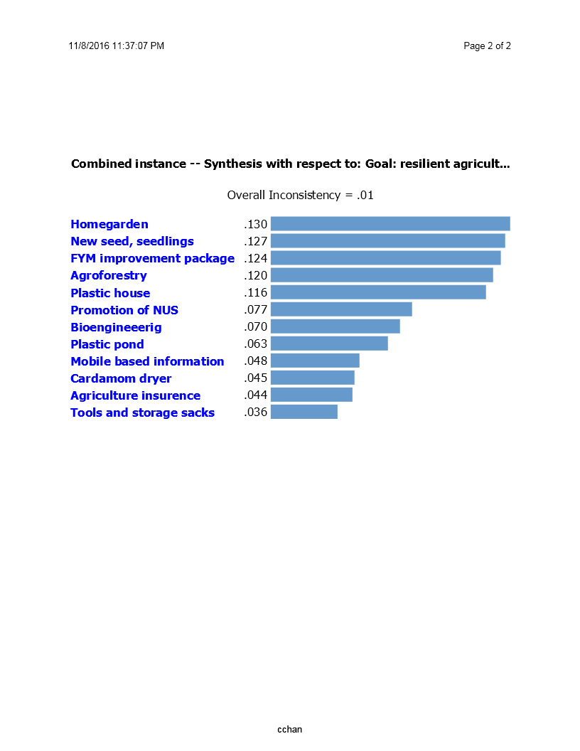

Female’s Perception

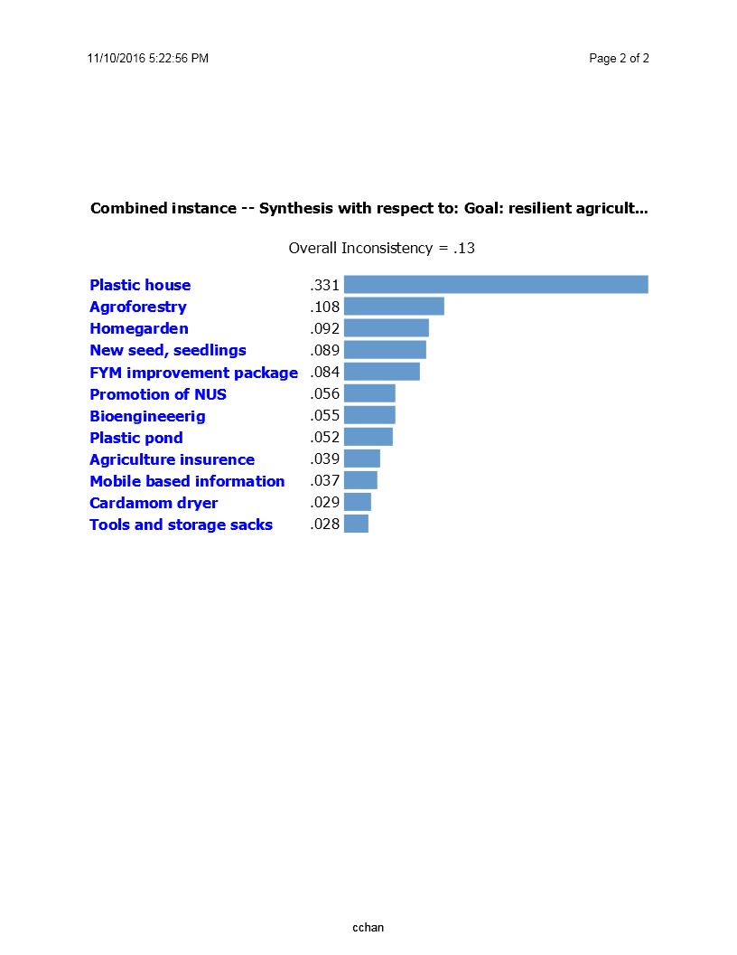

Male‘s Perception

Figure 5: Prioritization of CSAs by females and males in Ghanpokhara, Lamjung

In Kaski, there is greater agreement between men and women farmers on CSA ranking (Figure 5). Water smart technologies, such as ‘water-source protection’ and ‘plastic house and drip irrigation package’ ranked among two most important technology by both men and women groups. Understandably, women ranked ‘water source protection’ as most important because water is very scarce resource in village and making water available in household is principally regarded as women’s job. In contrary, men ranked ‘plastic house and drip irrigation package’ as their first choice because this package of technology creates new potential for income generation, even under the situation of limited water availability. Both men and women farmers’ groups provided lowest scores to ‘Yam farming in Sacs’, provision of ‘hand tools and machines’ and ‘mobile based agro-advisory service’. This is possibly due to lack of immediate returns from these CSAs to farmers.

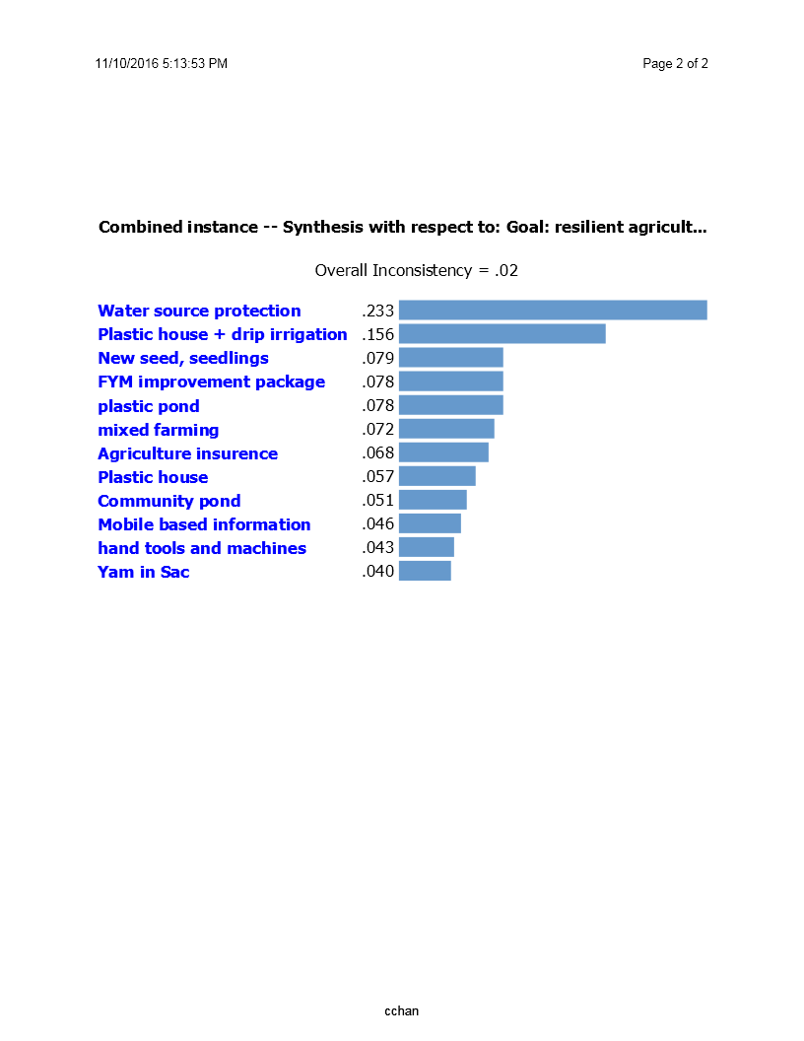

Female’s Perception

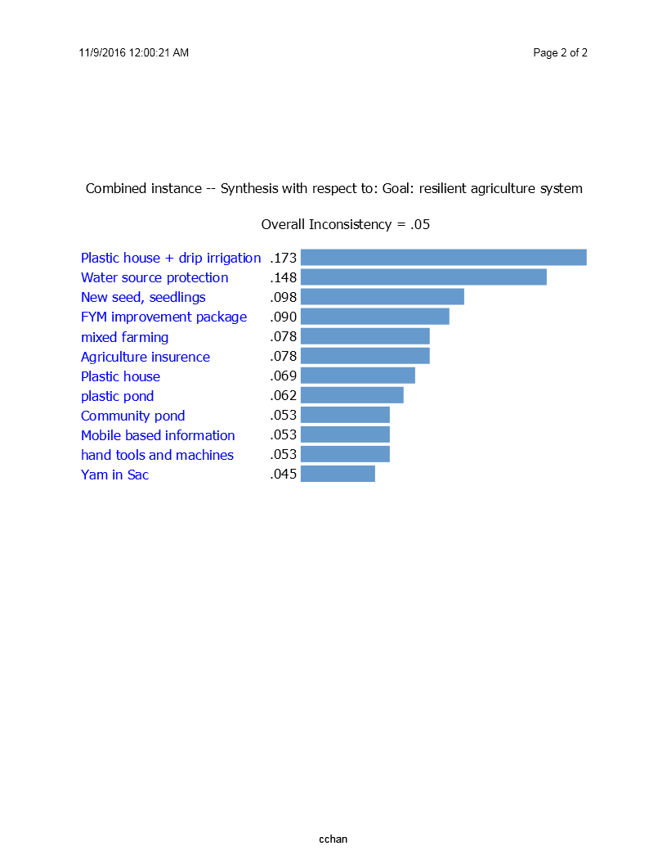

Male’s Perception

Figure 6: Prioritization of CSAs by females and males in mid-hill region (Majhthana, Kaski)

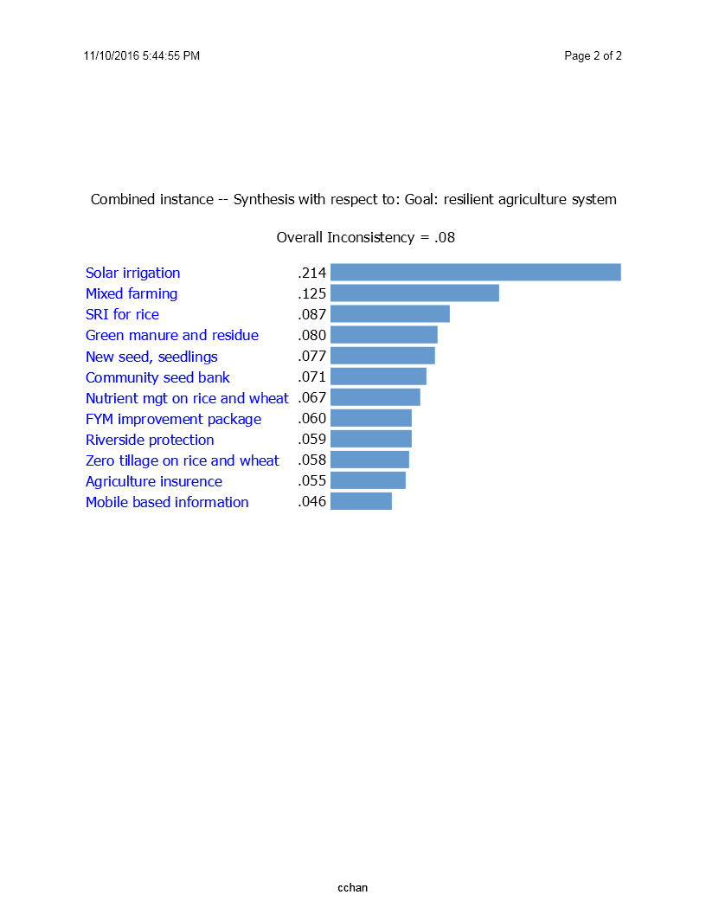

Female’s Perception

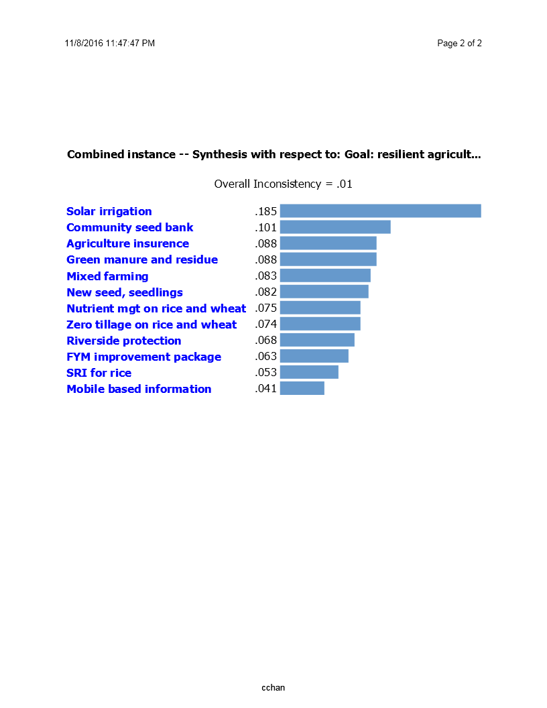

Male’s Perception

Figure 7: Prioritization of CSAs by females and males in Agyouli, Nawalparasi

In Nawalparasi, ‘solar based irrigation’ was prioritized overwhelmingly first CSA by both women and men farmers (Figure 6). This is reasonable since introduction of solar-based irrigation in water-stressed areas increases food production, support adaptation to droughts and immediately higher income by allowing higher cropping intensity. Similarly, there is agreement between both men and women groups that mobile-based agro-advisory is the least prioritized CSA. Although, farmers testimony in other occasions show that the mobile-based weather and market information has supported them in decision making, the result shows that farmers are not convinced about the value of this CSA, possibly due to either the message is not effective or farmers have not been able to use the message. There is some disagreements between men group and women groups while ranking remaining technologies in the middle. Mixed farming of cereal and legumes, SRI for rice etc. were prioritized high by female farmers while community seed banks and agriculture insurance were prioritized high by male farmers. However, the difference among the weights is too-narrow to ask for focused elaboration.

During the course of evaluation, it has been realized that the packages of technologies rather than the individual stand-alone technology is useful to address the growing challenges of climate change and to adapt the farming household in order to increase their food security and income. Hence, the study recommends packaging different technologies in one set of technology in order to meet the demand and need of households while tackling the problems and challenges posed by the changing climate and need to grow more.

**Box II**

**Packaging of CSA technologies and practices**

In order for CSA technologies and practices to be effective in any given condition, it has been found that the best suited technologies for any given region need to be packaged appropriately to make a standard set of CSA technology/practice (herein after referred as “CSA Packages”). This not only solve a single problem (as in case of stand-alone technology) but also be helpful in addressing multitude of related problems. One of the most prominent case is that related technology introduced to address water-stress condition. The project has intervened through water-source protection/improvement; rainwater and run-off water harvesting; renovation of community pond; gray water collection; using water for multiple purposes; etc. However, if these interventions is combined to make a set of CSA package, it is more effective to combat the water problem than the individual technologies.

**STEP III**

## CONSOLIDATION OF RESULTS FOR FINALIZING CHAMPION CSA

Several methods of data collection and analysis was finally consolidated through expert’s discussions for finalizing the numbers of CSAs for high-hill, mid-hill and terai regions. Special considerations were given to following three criteria while finalizing the CSAs for different agro-ecologies.

***Criteria for Consolidation***

1. **Potential to reduce climate vulnerability of the agro-ecology:** In baseline study, landslide and hailstone was identified as main vulnerability issue in high hill, while drought and water stress was main challenge in hill region. In terai, unpredictable rainfall, winter drought and flood were the main climatic vulnerability (Bhatta et al., 2015). Therefore, while finalizing champion CSAs, special attention was given to select those technology which can directly address the vulnerability issue in significant way.
2. **Potential to develop package of champion CSAs:** One or two standalone CSAs would not make much difference to resilience of overall system. As the target is building a resilient agro-ecosystem, special attention was given to identify CSAs which can be combined to develop a complete portfolio of CSAs for crop cultivation or agro-ecosystem management. Therefore, it was ensured that at least two champion CSAs are from each of water, weather, knowledge, carbon, nutrition, energy smart categories.
3. **Scalability:** The consolidation also follows the hypothesis that the Champion CSAs are scalable in the sense that there exists a favorable policy for its scaling-up, there are appropriate institutional setup for supporting its scaling-out, and there are appropriate financing mechanism, if needed.

***Champion CSAs for Different Agro-Ecological Regions of Nepal***

Since there were various methods of data collection and analysis, a group of experts, consisting of the project team and stakeholders, discussed the findings of each studies and applied expert-judgement to propose the final list of champion CSAs for high-hill, mid-hill and terai regions.

Table 9: Champion CSA technologies and practices

|  |  |  |  |  |
| --- | --- | --- | --- | --- |
| **Champion CSAs** | **High-hill** | **Mid-hill** | **Terai** | **Smartness** |
| Solar-based Irrigation |  |  | √ | Water and Energy Smart |
| Introduction of New Crops, Seeds, Varieties, Seedlings, etc. | √ | √ | √ | Weather and Knowledge Smart |
| Conservation Agriculture (Zero Tillage, Residue Retention) |  |  | √ | Carbon, Water, and weather Smart |
| Home Garden | √ | √ | √ | Weather and Knowledge Smart |
| Plastic Pond | √ | √ |  | Water Smart |
| Plastic House | √ |  |  | Weather and Water Smart |
| Drip Irrigation |  | √ |  | Water Smart |
| Cattle-shed Improvement | √ | √ |  | Nutrient and Carbon Smart |
| Package of Plastic Pond, Plastic House, Drip Irrigation, and Improved Cattle-shed | √ | √ |  | Water, Weather and Nutrient Smart |
| Mixed Farming (Legume Integration) | √ | √ | √ | Nutrient and Weather smart |
| Community Seed Banks | √ | √ | √ | Knowledge Smart |
| System of Rice Intensification |  |  | √ | Water Smart |
| Water Harvesting Ponds, Multiple Use and Water Source Protection | √ | √ |  | Water Smart |
| Plantation and Agro-forestry | √ | √ |  | Carbon Smart |
| Small Hand-Tools, Machines | √ | √ | √ | GESI and Labor/Energy Smart |
| Agriculture Insurance (particularly Index-based) | √ | √ | √ | Weather Smart |
| ICT-based Agro-advisory | √ | √ | √ | Knowledge and Weather Smart |
| **Total Number** | **9** | **12** | **10** |  |

Altogether, 17 CSAs or package of CSAs are finalized as champion CSAs for Nepal. Among them, 9 CSAs are champion for high-hill region, 12 CSAs are for mid-hill region and 10 CSAs are for terai region. Six CSAs (i.e. introduction of seeds/seedlings of new crops, improved home garden, varieties and breeds; mixed farming through legume integration, introduction of small hand-tools and machines, agriculture insurance and ICT based agro-advisory) are champions for all three agro-ecological regions since these CSAs are essential to enhance resilience of any agro-ecological system. The CSAs suitable for terai region only are crop based agronomic practices such as conservation agriculture (zero tillage plus residue management) for wheat and system of rice intensification (SRI) for rice. Community Seed Bank is identified as champion CSA since it acts as a docking stations for knowledge and information and it also increases communities’ access to diverse seeds. Despite high level of resilience gain, solar-based irrigation technology is only feasible for terai region because of unavailability of underground water in hills and mountains. Yet, solar-based pumping cab be applied for lifting irrigation in any place.

Due to high water scarcity problem in mid-hill region, water-smart CSAs such as water harvesting pond, multiple-use system and water source protection, plastic pond, drip irrigation appeared to be champion CSAs for the region. Particularly for mid-hill region, a package of plastic pond, plastic house, drip irrigation plus improved cattle-shed practice is best fitted for reducing weather vulnerability, ensuring efficient water and nutrient management and improving farmers’ income and profit.

The champion CSAs for high-hills are closely similar to mid-hill region, however farmers in high hill region provided lower importance to the water harvesting technologies. Considering the fact that the water-scarcity is more severe in mid-hills than in high-hills, this choice is understandable. Along with the six champion CSAs relevant to all three agro-ecology, plastic house technology is selected as champion to high hills. Due to long cold winter season, people in high-hill can hardly grow vegetables in winter season, hence technologies such as plastic house enables to cultivate vegetables throughout the year.

**STEP IV**

## VALIDATION AND FINALIZATION

***Validation with Farmers***

Focus group discussion was also conducted with farmers’ groups for finding out the most prominent technologies that had helped them combat the ill-effects of climate change. The pairwise-ranking method, one of participatory rural appraisal tool, was employed to rank the CSAs from first-to-last ranking. The main purpose of the exercise was to validate the list of champion CSAs selected through evaluation process by cross-checking. The result of the ranking exercise in all three sites closely matched to the result of the CSA evaluation exercise confirming the results of two methods of evaluation, hence the list of champion CSAs is validated with the farmers’ groups.

***Validation with Stakeholders***

The project has planned for a final outcome-sharing workshop inviting different stakeholders, from government to non-government and private sector, including the participation of Project Advisory Committee. It is also planned that the consolidated analysis for the selection of champion CSAs along with the rationale behind it will be presented in this workshop. The representation of PAC for this final verification and validation of the project findings ensures that PAC owns these findings. This will also help Government of Nepal to prepare appropriate policies in the future based on recommendation of the project. Comments and suggestions from this workshop will be incorporated before finalizing the list of champion CSAs.

# 3. Conclusion and Recommendation

This “Champion Screening Methodology” report builds on and completes the previous methodology report entitled “Identification and Piloting Methodology Report”. The combination of these two reports provides a complete steps for identification, prioritization, and piloting and evaluation process for selection of the champion CSAs through participatory action research method.

The results from the analysis showed that most of the CSAs piloted by the projects have increased the production and income of the participating households. They are also helpful to sustain their productivity in the changed climatic context. Some of them also helps minimize fossil fuel consumption rather use renewable energy sources. Plantation like activities also sequesters carbon and help minimize green-house gas effect. Various CSAs are found to be reducing women’s drudgery, workload, time uses, and distance to travel, heath, etc. hence beneficial for improving their condition. Many of these technologies and practices are also useful to enhance or improve the social status of the participating household and hence could be considered important for improving their social position.

It is evident that farmers considers income, productivity, and food security to be of utmost importance among the CSA pillars hence most of the CSAs prioritized by farmers are targeted for that goal. Thus results indicates that despite widespread visible signs of climate change, farmers see adaptation technologies as the part of broad agriculture development activities. Although there are some differences in the degree of importance provided by males groups and females groups for various CSA pillars, the findings largely conforms the weightage applied by the expert team to screen potential CSAs. Food security is first priority CSA pillar for both experts and farmers followed by adaptation. While GESI was given higher weight than mitigation by experts, it was given lesser priority in almost all sites by both men and women farmers. More disaggregated analysis based on caste group would have provided better light on this issue.

Revisiting the list of the CSAs by agro-ecological regions, CSAs such as plastic house, improved home garden, agro-forestry, provision of new seeds and seedlings and FYM improvement package are highly prioritized for high-hills. Water-smart technologies such as water source protection, water harvesting and plastic house plus drip irrigation; provision of new seeds and seedlings and FYM improvement package has received highest priority in mid-hill region. Finally, solar-based irrigation, legume-integration into cereal based farming system, community seed bank, SRI etc. were among the top priority

Finally, combined with ‘CSA Identification and Piloting Methodology Report’ submitted earlier, this ‘Champion Screening Methodology Report’ provides a complete framework to identify, prioritize, pilot, and evaluate the champion CSAs. The pillars/themes developed to define CSA for Nepal, criteria constructed for different pillars/themes, and indicators identified for each criteria; constitutes contribution to the art of knowledge for CSA discourse in Nepal and worldwide. The methodology developed in Nepal can be applied everywhere, although the CSA pillars, criteria and indicators may vary by location and conditions.

# 4. References

Bhatta, K. P., K. Thapa, S. Gautam, A. Khattri-Chhetri, P. Chaudhary, R. B. Rana, B. Dhakal, K. D. Gurung, and B. Bhattarai. 2015. Scaling-up Climate Smart Agriculture in Nepal-Village Baseline Report. Local Initiatives for Biodiversity, Research, and Development (LI-BIRD) and The Consultative Group for International Agricultural Research’s (CGIAR) Research Program on Climate Change, Agriculture, and Food Security (CCAFS), Kaski, Nepal.

Bhatta, K. P., P. Chaudhary, A. Khattri-Chhetri, K. Thapa, R. B. Rana, D. Gurung, D. Rijal. and B. Paudel. 2016. Scaling-up Climate Smart Agriculture in Nepal - Technology Identification and Piloting Methodology Report. Local Initiatives for Biodiversity, Research, and Development (LI-BIRD) and The Consultative Group for International Agricultural Research’s (CGIAR) Research Program on Climate Change, Agriculture, and Food Security (CCAFS), Kaski, Nepal.

IDS-Nepal, PAC, and GCAP. 2014. Economic Impact Assessment of Climate Change in Key Sectors in Nepa. Integrated Development Society Nepal, Practical Action Consulting, and the Global Climate Adaptation Partnership, Kathmandu, Nepal.

MoE. 2011. Climate Change Policy, 2011. Ministry of Environment, Government of Nepal, Kathmandu, Nepal.

Saaty, T. L. 1988. What is the Analytic Hierarchy Process? In: G. Mitra, H. J. Greenberg, F. A. Lootsma, M. J. Rijckaert and H. J. Zimmermann (Eds.). Mathematical Models for Decision Support: Pp. 109-21. Springer Berlin Heidelberg, Germany.

# 5. Annexes

Annex I: CSA technologies/practices tested and validated by different organizations working in Nepal

|  |  |  |
| --- | --- | --- |
| **Organization** | **Title of Research** | **Remarks** |
| Mott MacDonald and Partners | Making the irrigation systems resilient in the context of climate change in Nepal | Resilient irrigation is emphasized by this research and it is accepted as important component by CSA project. The project will package it into set of technologies for water stressed condition and a scaling-up pathways will be prepared for the same. |
| FORWARD-Nepal | Piloting of Nutrient Expert tool in rice, Wheat and maize: FORWARD Nepal’s experience in the eastern Terai | Though nutrient expert tool is important given low levels of inorganic fertilizer use in Nepal, further research is required for its scaling-out. |
| Gene Bank, NARC | Climate Analogue Tool (CAT) for smart planning in the wake of climate change | CAT is important tool and hence CSA project also employed it for preparing climate analogue maps based on available primary / secondary data. |
| CREEW-Nepal | Climate change impact on agriculture from the perspective of water resources | Water resources are important for agriculture and hence the CSA project accepted it as a crucial point especially in rainfed-based agriculture like Nepal. A package of technologies for addressing water stress has gone for preparing scaling-up pathways. |
| iDE-Nepal | Multiple Use Water System (MUS): A key climate smart technology for smallholders | MUS is again one of the important technology and hence it is also combined in the package of technology for water stressed condition and a scaling-up path for it will be prepared. |
| ICIMOD and CEAPRED-Nepal | Mountain smallholder farmers towards resilience practices: a case study from Kavre, Koshi Hills, Nepal | Climate Smart Village model is the emphasis of this research, which is accepted by the CSA project. |
| FAO | Economics of CSA for smallholder farmers in Nepal | FAO coined the term CSA. This research also emphasized the need for scaling-out CSA since the economic benefits are significantly higher. CSA project has already accepted this fact and is preparing scaling-up pathways for increasing the coverage of CSA technologies and practices. |
| SNV-Nepal | An inclusive approach to developing climate-smart solutions for mountain agriculture in Nepal | There are several technologies promoted by the research like snow harvesting; water use efficiency increasing; improved agronomic practices; agro-advisories; investment support; value chain participation; etc. Many of these technologies are already accepted in one way or other e.g. water harvesting, ICT-based agro-advisory, etc. Other aspects (like investment support, value-chain participation) will form the part of scaling-up strategy to be prepared for different individual technologies. |
| WWF-Nepal | Climate-smart Agriculture for Commercial Crops | This research emphasized knowledge management and Farmer Climate School has been emphasized as an important tool to disseminate knowledge. This again will be the component of scaling-up strategy rather than taking it as a CSA technology itself. |
| Practical Action Nepal | Up-scaling CSA through the private sectors | Private sector involvement has been shown to be important. The CSA project accepts is as one of the important aspect for scaling-up of CSA technologies and practices. |
| Helvetas Nepal | Scaling up sustainable soil management (SSM) practices in Nepal | Sustainable soil management is important CSA technology, which is also tested by CSA project. This has been well accepted by the GoN (MoAD) but to increase its coverage scaling-up pathways need to be developed. |
| NARC | Experiences of NARC on CSA Practices | There are several promising technologies like stress-tolerant varieties; agro-advisories; nutrient, tillage, and residue management; seed bank; hand-held agricultural tools; etc. These are accepted by the project to be important and several of them are accepted as champions and scaling-up pathways will be prepared for them. |
| Landel Mills Development Consultant | Biochar based organic fertilizer outweigh chemical fertilizer in cabbage and cauliflower production – farmers trial results in Bandipur (Tanahu) and Nalang (Dhading) villages of Nepal | SAKS project of LI-BIRD has also tested biochar with encouraging results but more research are needed to before it can be recommended as champion CSA. |
| MoAD / GoN | An initiative of ICT applications in agriculture/AMIS | CSA project has itself implemented ICT-based agro-advisory services and found it important but only after the sizeable volume of production is expected from the community for market sale. |
| ANSAB-Nepal | Ecosystem-based commercial Agriculture: Lessons from field experimentation and demonstration | Ecosystem approach is important and is being considered by the CSA project too. Commercialization is also important for farmers to increase income and food security. Commercialization, value-chain, financing mechanism, etc will be the component of scaling-up pathways developed by the project. Several technologies like plastic house, solar-based irrigation, etc are already promoted by CSA project. Some of these will be considered for preparing scaling-up pathways. |

Annex II: Household Survey Questionnaire



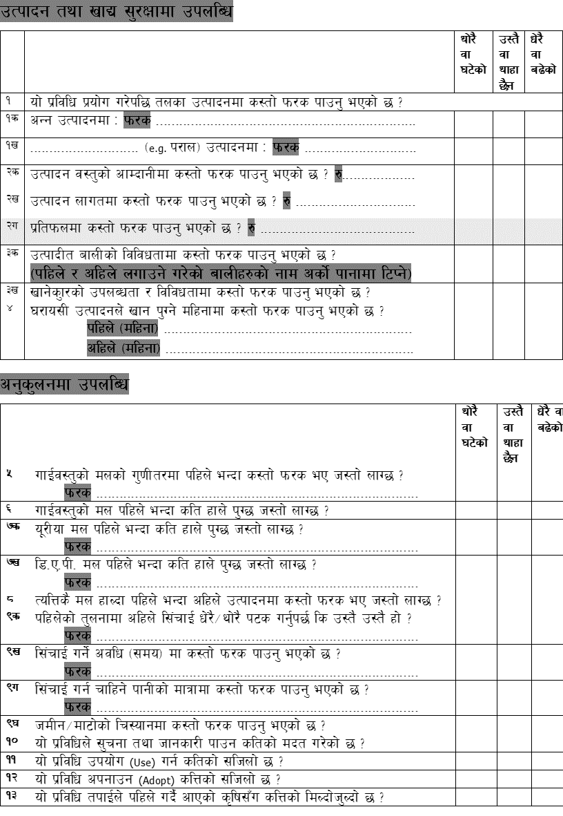











Annex III: Results from Household Survey (Ghanpokhara, Lamjung)

|  |  |  |  |  |  |  |
| --- | --- | --- | --- | --- | --- | --- |
| **Technologies**  **Indicators** | **Agroforestry** | | **Bioengineering** | | **Bio-Pesticide** | |
| **Increased** | **Decreased** | **Increased** | **Decreased** | **Increased** | **Decreased** |
| Sample Size | 21 | | 9 | | 12 | |
| Grain Production | 76 | 0 | 100 | 0 | 92 | 0 |
| Biomass Production | 33 | 0 | 100 | 0 | 83 | 0 |
| Income | 95 | 0 | 100 | 0 | 67 | 8 |
| Costs | 0 | 86 | 0 | 100 | 25 | 42 |
| Profit | 95 | 0 | 100 | 0 | 67 | 0 |
| Crop Diversity | 95 | 0 | 100 | 0 | 58 | 0 |
| Food Diversity | 90 | 0 | 100 | 0 | 50 | 0 |
| No. of Food Secure Months | 76 | 0 | 100 | 0 | 50 | 0 |
| Quality of Manure | 10 | 0 | 0 | 0 | 8 | 0 |
| Quantity of Manure Required | 5 | 10 | 0 | 0 | 0 | 0 |
| Urea Required | 0 | 10 | 0 | 0 | 0 | 0 |
| DAP Required | 0 | 5 | 0 | 0 | 0 | 0 |
| production with same amount of Fertilizer | 14 | 0 | 0 | 0 | 0 | 0 |
| Frequency of Irrigation | 0 | 0 | 0 | 0 | 0 | 0 |
| duration of irrigation | 0 | 0 | 0 | 0 | 0 | 0 |
| Difference in amount of water required for irrigation | 0 | 5 | 0 | 0 | 0 | 0 |
| soil moisture | 71 | 0 | 0 | 0 | 25 | 0 |
| Access to information due to Technology Adoption | 100 | 0 | 100 | 0 | 92 | 0 |
| Ease of Use of Technology | 90 | 0 | 100 | 0 | 92 | 0 |
| Ease of Adoption of Technology | 95 | 0 | 100 | 0 | 100 | 0 |
| Similarity with Indigenous Technology | 95 | 0 | 0 | 0 | 50 | 33 |
| Use of Machineries consuming Petroleum Products | 0 | 0 | 0 | 0 | 0 | 0 |
| Use of Petroleum | 0 | 0 | 0 | 0 | 0 | 0 |
| Ease of use of Renewable Energy | 5 | 0 | 0 | 0 | 0 | 0 |
| Labor use | 0 | 10 | 0 | 0 | 8 | 0 |
| use of Animal Power | 0 | 0 | 0 | 0 | 0 | 0 |
| use of Tractor (Machines) | 0 | 0 | 0 | 0 | 0 | 0 |
| Women’s labor time | 0 | 95 | 0 | 100 | 25 | 67 |
| Women’s Workload | 0 | 95 | 0 | 100 | 8 | 58 |
| Women’s distance from home to work | 0 | 95 | 0 | 100 | 17 | 42 |
| Women’s access to Information | 100 | 0 | 100 | 0 | 75 | 0 |
| Women’s Income | 86 | 0 | 100 | 0 | 92 | 0 |
| Women’s Health | 86 | 0 | 100 | 0 | 67 | 0 |
| Women’s Decision making capacity | 100 | 0 | 100 | 0 | 83 | 0 |
| Women’s Risk taking capacity | 100 | 0 | 100 | 0 | 83 | 0 |
| Women’s Engagement in social works | 100 | 0 | 100 | 0 | 92 | 0 |
| Women Joining Institutions/Groups | 95 | 0 | 100 | 0 | 83 | 0 |
| Women’s Leadership in Institutions/ Groups | 43 | 0 | 100 | 0 | 50 | 0 |
| Women’s Recognition in Society | 95 | 0 | 100 | 0 | 83 | 0 |
| Women’s perception of Society | 100 | 0 | 100 | 0 | 100 | 0 |
| Women’s Engagement in Social decision making | 100 | 0 | 100 | 0 | 83 | 0 |
| Women’s Representation in VDC | 52 | 0 | 100 | 0 | 67 | 0 |
| Women’s ability to allocate budget in VDC | 29 | 0 | 100 | 0 | 33 | 0 |
| DAG’s labor time | 0 | 95 | 0 | 100 | 17 | 67 |
| DAG’s Workload | 0 | 95 | 0 | 100 | 8 | 58 |
| DAG’s Distance from home to work | 0 | 95 | 0 | 100 | 17 | 42 |
| DAG’s Access to Information | 95 | 5 | 100 | 0 | 75 | 0 |
| DAG’s Income | 86 | 0 | 100 | 0 | 92 | 0 |
| DAG’s Health | 86 | 0 | 100 | 0 | 67 | 0 |
| DAG’s Decision making capacity | 100 | 0 | 100 | 0 | 92 | 0 |
| DAG’s Risk taking capacity | 100 | 0 | 100 | 0 | 75 | 0 |
| DAG’s Engagement in social works | 100 | 0 | 100 | 0 | 100 | 0 |
| DAG Joining Institutions/Groups | 95 | 0 | 100 | 0 | 83 | 0 |
| DAG’s Leadership in Institutions/ Groups | 33 | 0 | 100 | 0 | 58 | 0 |
| DAG’s Recognition in Society | 100 | 0 | 100 | 0 | 75 | 8 |
| DAG’s Improvement in perception of Society | 100 | 0 | 100 | 0 | 92 | 8 |
| DAG’s Engagement in Social decision making | 100 | 0 | 100 | 0 | 92 | 0 |
| DAG’s Representation in VDC | 52 | 0 | 100 | 0 | 58 | 0 |
| DAG’s ability to allocate budget in VDC | 19 | 0 | 100 | 0 | 17 | 0 |
| Helpful in addressing the current need | 100 | | 100 | | 100 | |
| Helpful in combating the climatic risk | 100 | | 100 | | 100 | |
| Helpful in taking advantage of climate change | 95 | | 100 | | 100 | |

DAG = disadvantaged groups (poor, Dalits and ethnic minorities)

|  |  |  |  |  |  |  |
| --- | --- | --- | --- | --- | --- | --- |
| **Technologies**  **Indicators** | **Cardamom Dryer** | | **Cattle-shed Improvement** | | **Nursery Establishment** | |
| **Increased** | **Decreased** | **Increased** | **Decreased** | **Increased** | **Decreased** |
| Sample Size | 10 | | 48 | | 2 | |
| Grain Production | 100 | 0 | 85 | 0 | 100 | 0 |
| Biomass Production | 0 | 0 | 69 | 0 | 0 | 0 |
| Income | 100 | 0 | 73 | 0 | 100 | 0 |
| Costs | 0 | 100 | 4 | 52 | 50 | 0 |
| Profit | 100 | 0 | 69 | 0 | 100 | 0 |
| Crop Diversity | 100 | 0 | 50 | 0 | 100 | 0 |
| Food Diversity | 100 | 0 | 52 | 0 | 100 | 0 |
| No. of Food Secure Months | 100 | 0 | 56 | 4 | 50 | 0 |
| Quality of Manure | 0 | 0 | 85 | 0 | 0 | 0 |
| Quantity of Manure Required | 0 | 0 | 4 | 63 | 0 | 0 |
| Urea Required | 0 | 0 | 0 | 15 | 0 | 0 |
| DAP Required | 0 | 0 | 0 | 4 | 0 | 0 |
| production with same amount of Fertilizer | 0 | 0 | 65 | 0 | 0 | 0 |
| Frequency of Irrigation | 0 | 0 | 0 | 8 | 50 | 0 |
| duration of irrigation | 0 | 0 | 0 | 6 | 50 | 0 |
| Difference in amount of water required for irrigation | 0 | 0 | 0 | 8 | 0 | 0 |
| soil moisture | 100 | 0 | 54 | 0 | 0 | 0 |
| Access to information due to Technology Adoption | 100 | 0 | 67 | 0 | 50 | 0 |
| Ease of Use of Technology | 100 | 0 | 85 | 0 | 100 | 0 |
| Ease of Adoption of Technology | 100 | 0 | 90 | 0 | 100 | 0 |
| Similarity with Indigenous Technology | 100 | 0 | 71 | 0 | 50 | 0 |
| Use of Machineries consuming Petroleum Products | 0 | 100 | 4 | 2 | 0 | 0 |
| Use of Petroleum | 0 | 0 | 2 | 2 | 0 | 0 |
| Ease of use of Renewable Energy | 0 | 0 | 10 | 0 | 0 | 0 |
| Labor use | 0 | 0 | 4 | 35 | 0 | 0 |
| use of Animal Power | 0 | 0 | 0 | 0 | 0 | 0 |
| use of Tractor (Machines) | 0 | 0 | 0 | 0 | 0 | 0 |
| Women’s labor time | 0 | 100 | 4 | 75 | 50 | 0 |
| Women’s Workload | 0 | 100 | 0 | 75 | 50 | 0 |
| Women’s distance from home to work | 0 | 100 | 0 | 54 | 0 | 0 |
| Women’s access to Information | 100 | 0 | 67 | 0 | 50 | 0 |
| Women’s Income | 100 | 0 | 71 | 0 | 50 | 0 |
| Women’s Health | 100 | 0 | 75 | 0 | 50 | 0 |
| Women’s Decision making capacity | 100 | 0 | 71 | 0 | 100 | 0 |
| Women’s Risk taking capacity | 100 | 0 | 63 | 0 | 100 | 0 |
| Women’s Engagement in social works | 100 | 0 | 83 | 0 | 100 | 0 |
| Women Joining Institutions/Groups | 100 | 0 | 79 | 4 | 100 | 0 |
| Women’s Leadership in Institutions/ Groups | 100 | 0 | 46 | 0 | 100 | 0 |
| Women’s Recognition in Society | 100 | 0 | 77 | 0 | 100 | 0 |
| Women’s perception of Society | 100 | 0 | 79 | 0 | 100 | 0 |
| Women’s Engagement in Social decision making | 100 | 0 | 85 | 0 | 100 | 0 |
| Women’s Representation in VDC | 100 | 0 | 58 | 0 | 50 | 0 |
| Women’s ability to allocate budget in VDC | 100 | 0 | 31 | 0 | 0 | 0 |
| DAG’s labor time | 0 | 100 | 4 | 75 | 0 | 0 |
| DAG’s Workload | 0 | 100 | 0 | 75 | 0 | 0 |
| DAG’s Distance from home to work | 0 | 100 | 4 | 58 | 0 | 0 |
| DAG’s Access to Information | 100 | 0 | 71 | 0 | 0 | 0 |
| DAG’s Income | 100 | 0 | 73 | 0 | 0 | 0 |
| DAG’s Health | 100 | 0 | 73 | 0 | 0 | 0 |
| DAG’s Decision making capacity | 100 | 0 | 67 | 0 | 50 | 0 |
| DAG’s Risk taking capacity | 100 | 0 | 63 | 0 | 50 | 0 |
| DAG’s Engagement in social works | 100 | 0 | 88 | 0 | 100 | 0 |
| DAG Joining Institutions/Groups | 0 | 0 | 75 | 4 | 100 | 0 |
| DAG’s Leadership in Institutions/ Groups | 0 | 0 | 35 | 0 | 100 | 0 |
| DAG’s Recognition in Society | 100 | 0 | 81 | 0 | 100 | 0 |
| DAG’s Improvement in perception of Society | 100 | 0 | 83 | 2 | 100 | 0 |
| DAG’s Engagement in Social decision making | 100 | 0 | 85 | 0 | 100 | 0 |
| DAG’s Representation in VDC | 100 | 0 | 69 | 0 | 0 | 0 |
| DAG’s ability to allocate budget in VDC | 0 | 0 | 29 | 0 | 0 | 0 |
| Helpful in addressing the current need | 100 | | 100 | | 100 | |
| Helpful in combating the climatic risk | 100 | | 100 | | 100 | |
| Helpful in taking advantage of climate change | 100 | | 100 | | 100 | |

|  |  |  |  |  |  |  |
| --- | --- | --- | --- | --- | --- | --- |
| **Technologies**  **Indicators** | **Home Garden** | | **ICT-based Agro-advisory** | | **New Seeds and Varieties** | |
| **Increased** | **Decreased** | **Increased** | **Decreased** | **Increased** | **Decreased** |
| Sample Size | 21 | | 30 | | 78 | |
| Grain Production | 81 | 0 | 40 | 0 | 51 | 13 |
| Biomass Production | 5 | 0 | 33 | 0 | 22 | 6 |
| Income | 86 | 0 | 30 | 0 | 42 | 9 |
| Costs | 14 | 71 | 0 | 13 | 8 | 24 |
| Profit | 86 | 0 | 17 | 0 | 32 | 5 |
| Crop Diversity | 86 | 0 | 17 | 0 | 44 | 1 |
| Food Diversity | 90 | 0 | 20 | 0 | 44 | 1 |
| No. of Food Secure Months | 81 | 5 | 17 | 0 | 24 | 6 |
| Quality of Manure | 5 | 0 | 0 | 0 | 0 | 0 |
| Quantity of Manure Required | 0 | 0 | 0 | 0 | 0 | 1 |
| Urea Required | 0 | 0 | 0 | 0 | 0 | 0 |
| DAP Required | 0 | 0 | 0 | 0 | 0 | 0 |
| production with same amount of Fertilizer | 10 | 0 | 7 | 0 | 5 | 0 |
| Frequency of Irrigation | 0 | 0 | 0 | 0 | 1 | 0 |
| duration of irrigation | 0 | 0 | 0 | 0 | 0 | 1 |
| Difference in amount of water required for irrigation | 5 | 0 | 0 | 0 | 1 | 0 |
| soil moisture | 19 | 0 | 3 | 0 | 15 | 0 |
| Access to information due to Technology Adoption | 81 | 0 | 90 | 0 | 50 | 0 |
| Ease of Use of Technology | 86 | 0 | 93 | 0 | 56 | 1 |
| Ease of Adoption of Technology | 81 | 0 | 83 | 10 | 62 | 3 |
| Similarity with Indigenous Technology | 67 | 0 | 33 | 37 | 26 | 0 |
| Use of Machineries consuming Petroleum Products | 0 | 0 | 0 | 0 | 0 | 0 |
| Use of Petroleum | 0 | 0 | 0 | 0 | 0 | 0 |
| Ease of use of Renewable Energy | 5 | 0 | 0 | 0 | 0 | 0 |
| Labor use | 5 | 14 | 0 | 0 | 0 | 5 |
| use of Animal Power | 0 | 0 | 0 | 0 | 0 | 0 |
| use of Tractor (Machines) | 0 | 0 | 0 | 0 | 0 | 0 |
| Women’s labor time | 10 | 67 | 3 | 60 | 12 | 29 |
| Women’s Workload | 0 | 81 | 3 | 50 | 9 | 32 |
| Women’s distance from home to work | 0 | 52 | 0 | 47 | 6 | 26 |
| Women’s access to Information | 81 | 5 | 97 | 3 | 72 | 0 |
| Women’s Income | 90 | 5 | 60 | 7 | 47 | 22 |
| Women’s Health | 81 | 0 | 37 | 3 | 40 | 0 |
| Women’s Decision making capacity | 90 | 0 | 77 | 0 | 64 | 0 |
| Women’s Risk taking capacity | 86 | 0 | 80 | 0 | 63 | 1 |
| Women’s Engagement in social works | 95 | 0 | 90 | 0 | 88 | 0 |
| Women Joining Institutions/Groups | 76 | 0 | 90 | 0 | 86 | 0 |
| Women’s Leadership in Institutions/ Groups | 43 | 0 | 67 | 0 | 60 | 0 |
| Women’s Recognition in Society | 90 | 0 | 83 | 0 | 79 | 0 |
| Women’s perception of Society | 95 | 0 | 80 | 0 | 85 | 0 |
| Women’s Engagement in Social decision making | 95 | 0 | 87 | 0 | 91 | 0 |
| Women’s Representation in VDC | 43 | 0 | 47 | 0 | 50 | 0 |
| Women’s ability to allocate budget in VDC | 24 | 0 | 37 | 0 | 35 | 0 |
| DAG’s labor time | 10 | 67 | 3 | 57 | 10 | 33 |
| DAG’s Workload | 0 | 86 | 3 | 50 | 9 | 31 |
| DAG’s Distance from home to work | 5 | 57 | 0 | 47 | 9 | 22 |
| DAG’s Access to Information | 81 | 5 | 93 | 3 | 67 | 1 |
| DAG’s Income | 100 | 0 | 70 | 3 | 49 | 17 |
| DAG’s Health | 81 | 0 | 40 | 0 | 38 | 0 |
| DAG’s Decision making capacity | 95 | 0 | 77 | 0 | 59 | 1 |
| DAG’s Risk taking capacity | 81 | 0 | 80 | 0 | 65 | 3 |
| DAG’s Engagement in social works | 95 | 0 | 87 | 0 | 86 | 0 |
| DAG Joining Institutions/Groups | 76 | 0 | 90 | 0 | 82 | 1 |
| DAG’s Leadership in Institutions/ Groups | 43 | 0 | 60 | 0 | 50 | 0 |
| DAG’s Recognition in Society | 95 | 0 | 90 | 0 | 81 | 0 |
| DAG’s Improvement in perception of Society | 95 | 0 | 83 | 3 | 83 | 3 |
| DAG’s Engagement in Social decision making | 95 | 0 | 87 | 0 | 85 | 0 |
| DAG’s Representation in VDC | 48 | 0 | 43 | 0 | 49 | 0 |
| DAG’s ability to allocate budget in VDC | 29 | 0 | 27 | 0 | 29 | 0 |
| Helpful in addressing the current need | 95 | | 100 | | 45 | |
| Helpful in combating the climatic risk | 90 | | 93 | | 41 | |
| Helpful in taking advantage of climate change | 90 | | 87 | | 49 | |

|  |  |  |  |  |  |  |
| --- | --- | --- | --- | --- | --- | --- |
| **Technologies**  **Indicators** | **Neglected and Underutilized Crops** | | **Plastic House** | | **Plastic Pond** | |
| **Increased** | **Decreased** | **Increased** | **Decreased** | **Increased** | **Decreased** |
| Sample Size | 11 | | 28 | | 8 | |
| Grain Production | 100 | 0 | 93 | 0 | 100 | 0 |
| Biomass Production | 9 | 0 | 11 | 0 | 50 | 0 |
| Income | 91 | 0 | 100 | 0 | 100 | 0 |
| Costs | 0 | 91 | 4 | 96 | 0 | 100 |
| Profit | 91 | 0 | 100 | 0 | 75 | 0 |
| Crop Diversity | 91 | 0 | 86 | 0 | 75 | 0 |
| Food Diversity | 91 | 0 | 93 | 0 | 100 | 0 |
| No. of Food Secure Months | 73 | 0 | 93 | 0 | 88 | 0 |
| Quality of Manure | 0 | 0 | 4 | 0 | 13 | 0 |
| Quantity of Manure Required | 0 | 0 | 0 | 14 | 0 | 25 |
| Urea Required | 0 | 0 | 0 | 0 | 0 | 0 |
| DAP Required | 9 | 0 | 0 | 0 | 0 | 0 |
| production with same amount of Fertilizer | 45 | 0 | 50 | 0 | 38 | 0 |
| Frequency of Irrigation | 0 | 0 | 7 | 54 | 25 | 25 |
| duration of irrigation | 0 | 0 | 0 | 64 | 25 | 13 |
| Difference in amount of water required for irrigation | 0 | 0 | 7 | 39 | 0 | 38 |
| soil moisture | 9 | 0 | 86 | 0 | 88 | 0 |
| Access to information due to Technology Adoption | 100 | 0 | 86 | 0 | 100 | 0 |
| Ease of Use of Technology | 100 | 0 | 100 | 0 | 100 | 0 |
| Ease of Adoption of Technology | 100 | 0 | 96 | 4 | 100 | 0 |
| Similarity with Indigenous Technology | 100 | 0 | 79 | 18 | 63 | 25 |
| Use of Machineries consuming Petroleum Products | 0 | 0 | 0 | 0 | 0 | 0 |
| Use of Petroleum | 0 | 0 | 0 | 0 | 0 | 0 |
| Ease of use of Renewable Energy | 0 | 0 | 11 | 0 | 25 | 0 |
| Labor use | 0 | 0 | 4 | 32 | 0 | 38 |
| use of Animal Power | 0 | 0 | 0 | 18 | 0 | 0 |
| use of Tractor (Machines) | 0 | 0 | 0 | 0 | 0 | 0 |
| Women’s labor time | 0 | 100 | 0 | 96 | 13 | 88 |
| Women’s Workload | 0 | 100 | 0 | 96 | 13 | 88 |
| Women’s distance from home to work | 0 | 27 | 0 | 64 | 0 | 75 |
| Women’s access to Information | 100 | 0 | 96 | 4 | 100 | 0 |
| Women’s Income | 100 | 0 | 96 | 4 | 88 | 0 |
| Women’s Health | 100 | 0 | 86 | 4 | 88 | 0 |
| Women’s Decision making capacity | 100 | 0 | 93 | 0 | 88 | 0 |
| Women’s Risk taking capacity | 64 | 0 | 82 | 0 | 100 | 0 |
| Women’s Engagement in social works | 73 | 0 | 100 | 0 | 100 | 0 |
| Women Joining Institutions/Groups | 64 | 0 | 89 | 0 | 100 | 0 |
| Women’s Leadership in Institutions/ Groups | 55 | 0 | 68 | 0 | 50 | 0 |
| Women’s Recognition in Society | 100 | 0 | 89 | 0 | 75 | 0 |
| Women’s perception of Society | 100 | 0 | 89 | 0 | 88 | 0 |
| Women’s Engagement in Social decision making | 100 | 0 | 96 | 0 | 100 | 0 |
| Women’s Representation in VDC | 55 | 0 | 54 | 4 | 63 | 13 |
| Women’s ability to allocate budget in VDC | 55 | 0 | 32 | 4 | 38 | 13 |
| DAG’s labor time | 0 | 100 | 0 | 96 | 13 | 88 |
| DAG’s Workload | 0 | 100 | 0 | 96 | 13 | 88 |
| DAG’s Distance from home to work | 9 | 9 | 0 | 64 | 0 | 75 |
| DAG’s Access to Information | 100 | 0 | 86 | 4 | 75 | 0 |
| DAG’s Income | 100 | 0 | 96 | 4 | 100 | 0 |
| DAG’s Health | 100 | 0 | 86 | 4 | 100 | 0 |
| DAG’s Decision making capacity | 100 | 0 | 89 | 0 | 100 | 0 |
| DAG’s Risk taking capacity | 45 | 0 | 82 | 0 | 88 | 0 |
| DAG’s Engagement in social works | 55 | 0 | 93 | 0 | 75 | 0 |
| DAG Joining Institutions/Groups | 55 | 0 | 89 | 0 | 75 | 0 |
| DAG’s Leadership in Institutions/ Groups | 45 | 0 | 54 | 0 | 25 | 0 |
| DAG’s Recognition in Society | 91 | 0 | 86 | 0 | 88 | 0 |
| DAG’s Improvement in perception of Society | 100 | 0 | 86 | 0 | 100 | 0 |
| DAG’s Engagement in Social decision making | 100 | 0 | 96 | 0 | 100 | 0 |
| DAG’s Representation in VDC | 18 | 0 | 61 | 0 | 63 | 0 |
| DAG’s ability to allocate budget in VDC | 18 | 0 | 25 | 0 | 25 | 0 |
| Helpful in addressing the current need | 100 | | 100 | | 100 | |
| Helpful in combating the climatic risk | 100 | | 100 | | 100 | |
| Helpful in taking advantage of climate change | 100 | | 96 | | 100 | |

Annex IV: Results from Household Survey (Majhthana, Kaski)

|  |  |  |  |  |  |  |
| --- | --- | --- | --- | --- | --- | --- |
| **Technologies**  **Indicators** | **Cattle-shed Improvement** | | **Community Pond Rehabilitation** | | **Corn Sheller** | |
| **Increased** | **Decreased** | **Increased** | **Decreased** | **Increased** | **Decreased** |
| Sample Size | 26 | | 13 | | 20 | |
| Grain Production | 85 | 4 | 8 | 0 | 5 | 0 |
| Biomass Production | 73 | 0 | 0 | 0 | 20 | 0 |
| Income | 54 | 8 | 46 | 0 | 15 | 0 |
| Cost | 19 | 19 | 15 | 8 | 5 | 30 |
| Profit | 35 | 0 | 38 | 0 | 35 | 0 |
| Crop Diversity | 46 | 0 | 8 | 0 | 5 | 0 |
| Food Diversity | 31 | 0 | 8 | 0 | 20 | 0 |
| No. of Food Secure Months | 46 | 0 | 15 | 8 | 15 | 0 |
| Quality of Manure | 92 | 0 | 0 | 0 | 0 | 0 |
| Quantity of Manure Required | 8 | 62 | 0 | 0 | 0 | 0 |
| Urea Required | 0 | 46 | 0 | 0 | 0 | 0 |
| DAP Required | 0 | 38 | 0 | 0 | 0 | 0 |
| production with same amount of Fertilizer | 65 | 0 | 0 | 0 | 0 | 0 |
| Frequency of Irrigation | 0 | 4 | 0 | 0 | 0 | 0 |
| duration of irrigation | 0 | 4 | 0 | 0 | 0 | 0 |
| Difference in amount of water required for irrigation | 0 | 8 | 0 | 0 | 0 | 0 |
| soil moisture | 23 | 0 | 0 | 0 | 0 | 0 |
| Access to information due to Technology Adoption | 65 | 0 | 92 | 0 | 25 | 0 |
| Ease of Use of Technology | 92 | 8 | 100 | 0 | 100 | 0 |
| Ease of Adoption of Technology | 85 | 15 | 100 | 0 | 100 | 0 |
| Similarity with Indigenous Technology | 62 | 0 | 31 | 0 | 15 | 85 |
| Use of Machineries consuming Petroleum Products | 0 | 4 | 0 | 8 | 0 | 0 |
| Use of Petroleum | 0 | 8 | 0 | 0 | 0 | 0 |
| Ease of use of Renewable Energy | 0 | 0 | 0 | 0 | 0 | 0 |
| Labor use | 0 | 62 | 0 | 46 | 0 | 80 |
| use of Animal Power | 0 | 27 | 0 | 0 | 0 | 0 |
| use of Tractor (Machines) | 0 | 0 | 0 | 0 | 0 | 0 |
| Women’s labor time | 4 | 88 | 0 | 100 | 0 | 95 |
| Women’s Workload | 0 | 92 | 0 | 100 | 0 | 100 |
| Women’s distance from home to work | 0 | 19 | 8 | 92 | 0 | 15 |
| Women’s access to Information | 77 | 4 | 85 | 0 | 75 | 0 |
| Women’s Income | 73 | 0 | 69 | 0 | 65 | 0 |
| Women’s Health | 73 | 4 | 100 | 0 | 90 | 0 |
| Women’s Decision making capacity | 65 | 4 | 85 | 0 | 80 | 0 |
| Women’s Risk taking capacity | 65 | 0 | 85 | 0 | 80 | 0 |
| Women’s Engagement in social works | 77 | 0 | 85 | 0 | 80 | 5 |
| Women Joining Institutions/Groups | 73 | 0 | 85 | 0 | 80 | 0 |
| Women’s Leadership in Institutions/ Groups | 42 | 0 | 62 | 0 | 45 | 0 |
| Women’s Recognition in Society | 65 | 4 | 92 | 0 | 80 | 0 |
| Women’s perception of Society | 73 | 0 | 92 | 0 | 90 | 0 |
| Women’s Engagement in Social decision making | 73 | 0 | 85 | 0 | 80 | 0 |
| Women’s Representation in VDC | 54 | 0 | 85 | 0 | 60 | 0 |
| Women’s ability to allocate budget in VDC | 38 | 0 | 62 | 0 | 15 | 0 |
| DAG’s labor time | 8 | 81 | 0 | 100 | 0 | 95 |
| DAG’s Workload | 0 | 88 | 0 | 100 | 0 | 100 |
| DAG’s Distance from home to work | 0 | 27 | 0 | 100 | 0 | 15 |
| DAG’s Access to Information | 85 | 0 | 100 | 0 | 75 | 0 |
| DAG’s Income | 81 | 0 | 100 | 0 | 65 | 0 |
| DAG’s Health | 73 | 0 | 100 | 0 | 90 | 0 |
| DAG’s Decision making capacity | 73 | 0 | 85 | 0 | 80 | 0 |
| DAG’s Risk taking capacity | 73 | 0 | 85 | 0 | 80 | 0 |
| DAG’s Engagement in social works | 77 | 0 | 92 | 0 | 85 | 0 |
| DAG Joining Institutions/Groups | 77 | 0 | 85 | 0 | 80 | 0 |
| DAG’s Leadership in Institutions/ Groups | 62 | 0 | 77 | 0 | 50 | 0 |
| DAG’s Recognition in Society | 73 | 0 | 85 | 0 | 75 | 0 |
| DAG’s Improvement in perception of Society | 69 | 0 | 92 | 0 | 90 | 0 |
| DAG’s Engagement in Social decision making | 73 | 4 | 92 | 0 | 80 | 0 |
| DAG’s Representation in VDC | 69 | 4 | 85 | 0 | 60 | 0 |
| DAG’s ability to allocate budget in VDC | 50 | 0 | 69 | 0 | 20 | 0 |
| Helpful in addressing the current need | 100 | | 92 | | 80 | |
| Helpful in combating the climatic risk | 96 | | 92 | | 15 | |
| Helpful in taking advantage of climate change | 81 | | 92 | | 10 | |

|  |  |  |  |  |  |  |  |  |
| --- | --- | --- | --- | --- | --- | --- | --- | --- |
| **Technologies**  **Indicators** | **Grain Pro Bag** | | **ICT-based Agro-advisory** | | **Jab Planter** | | **Maize Ginger Inter-Cropping** | |
| **Increased** | **Decreased** | **Increased** | **Decreased** | **Increased** | **Decreased** | **Increased** | **Decreased** |
| Sample Size | 31 | | 22 | | 6 | | 12 | |
| Grain Production | 19 | 0 | 50 | 0 | 67 | 0 | 100 | 0 |
| Biomass Production | 13 | 0 | 36 | 0 | 17 | 0 | 100 | 0 |
| Income | 16 | 0 | 45 | 0 | 17 | 0 | 100 | 0 |
| Cost | 6 | 6 | 0 | 9 | 17 | 17 | 8 | 50 |
| Profit | 10 | 0 | 32 | 0 | 33 | 17 | 33 | 0 |
| Crop Diversity | 10 | 0 | 41 | 0 | 33 | 0 | 42 | 0 |
| Food Diversity | 19 | 0 | 36 | 0 | 17 | 0 | 75 | 0 |
| No. of Food Secure Months | 3 | 0 | 23 | 0 | 17 | 0 | 33 | 0 |
| Quality of Manure | 0 | 0 | 0 | 0 | 0 | 0 | 0 | 8 |
| Quantity of Manure Required | 0 | 0 | 0 | 0 | 0 | 0 | 17 | 25 |
| Urea Required | 0 | 0 | 0 | 0 | 0 | 0 | 8 | 33 |
| DAP Required | 0 | 0 | 0 | 0 | 0 | 0 | 8 | 8 |
| production with same amount of Fertilizer | 0 | 0 | 0 | 0 | 0 | 0 | 33 | 0 |
| Frequency of Irrigation | 3 | 0 | 0 | 0 | 0 | 0 | 8 | 0 |
| duration of irrigation | 3 | 0 | 0 | 0 | 0 | 0 | 0 | 0 |
| Difference in amount of water required for irrigation | 0 | 0 | 0 | 0 | 0 | 0 | 17 | 0 |
| soil moisture | 0 | 3 | 0 | 0 | 0 | 0 | 58 | 0 |
| Access to information due to Technology Adoption | 55 | 0 | 86 | 0 | 50 | 0 | 83 | 0 |
| Ease of Use of Technology | 77 | 0 | 86 | 5 | 100 | 0 | 100 | 0 |
| Ease of Adoption of Technology | 81 | 0 | 86 | 5 | 100 | 0 | 100 | 0 |
| Similarity with Indigenous Technology | 35 | 10 | 50 | 32 | 50 | 0 | 75 | 8 |
| Use of Machineries consuming Petroleum Products | 0 | 0 | 0 | 5 | 0 | 33 | 0 | 8 |
| Use of Petroleum | 0 | 0 | 0 | 0 | 0 | 0 | 0 | 0 |
| Ease of use of Renewable Energy | 0 | 0 | 0 | 0 | 0 | 0 | 0 | 0 |
| Labor use | 0 | 10 | 0 | 18 | 0 | 50 | 25 | 67 |
| use of Animal Power | 0 | 0 | 0 | 0 | 0 | 17 | 0 | 25 |
| use of Tractor (Machines) | 0 | 0 | 0 | 0 | 0 | 0 | 0 | 0 |
| Women’s labor time | 0 | 39 | 0 | 82 | 0 | 100 | 17 | 67 |
| Women’s Workload | 0 | 26 | 0 | 82 | 0 | 100 | 8 | 58 |
| Women’s distance from home to work | 0 | 6 | 0 | 86 | 0 | 67 | 8 | 33 |
| Women’s access to Information | 58 | 0 | 91 | 5 | 50 | 0 | 83 | 0 |
| Women’s Income | 42 | 0 | 68 | 5 | 83 | 0 | 92 | 0 |
| Women’s Health | 61 | 0 | 45 | 0 | 83 | 0 | 83 | 0 |
| Women’s Decision making capacity | 65 | 0 | 91 | 0 | 83 | 0 | 100 | 0 |
| Women’s Risk taking capacity | 65 | 0 | 91 | 0 | 67 | 0 | 100 | 0 |
| Women’s Engagement in social works | 74 | 0 | 86 | 0 | 83 | 0 | 92 | 0 |
| Women Joining Institutions/Groups | 68 | 0 | 86 | 0 | 83 | 0 | 100 | 0 |
| Women’s Leadership in Institutions/ Groups | 39 | 0 | 73 | 0 | 67 | 0 | 58 | 0 |
| Women’s Recognition in Society | 68 | 0 | 86 | 0 | 83 | 0 | 92 | 0 |
| Women’s perception of Society | 68 | 0 | 86 | 0 | 83 | 0 | 92 | 0 |
| Women’s Engagement in Social decision making | 71 | 0 | 86 | 0 | 83 | 0 | 92 | 0 |
| Women’s Representation in VDC | 55 | 3 | 73 | 0 | 67 | 0 | 83 | 0 |
| Women’s ability to allocate budget in VDC | 23 | 0 | 41 | 0 | 0 | 0 | 25 | 0 |
| DAG’s labor time | 0 | 39 | 0 | 82 | 0 | 83 | 8 | 83 |
| DAG’s Workload | 3 | 23 | 0 | 82 | 0 | 83 | 8 | 75 |
| DAG’s Distance from home to work | 0 | 3 | 0 | 86 | 0 | 67 | 0 | 50 |
| DAG’s Access to Information | 58 | 0 | 95 | 0 | 50 | 0 | 83 | 0 |
| DAG’s Income | 48 | 0 | 73 | 0 | 67 | 0 | 92 | 0 |
| DAG’s Health | 61 | 0 | 55 | 0 | 67 | 0 | 83 | 0 |
| DAG’s Decision making capacity | 65 | 0 | 86 | 0 | 67 | 0 | 100 | 0 |
| DAG’s Risk taking capacity | 68 | 0 | 86 | 0 | 67 | 0 | 100 | 0 |
| DAG’s Engagement in social works | 74 | 0 | 86 | 0 | 67 | 0 | 100 | 0 |
| DAG Joining Institutions/Groups | 61 | 0 | 82 | 0 | 67 | 0 | 92 | 0 |
| DAG’s Leadership in Institutions/ Groups | 42 | 0 | 68 | 0 | 33 | 0 | 92 | 0 |
| DAG’s Recognition in Society | 65 | 0 | 82 | 0 | 67 | 0 | 100 | 0 |
| DAG’s Improvement in perception of Society | 68 | 0 | 82 | 0 | 67 | 0 | 100 | 0 |
| DAG’s Engagement in Social decision making | 68 | 0 | 82 | 0 | 67 | 0 | 100 | 0 |
| DAG’s Representation in VDC | 55 | 0 | 64 | 0 | 67 | 0 | 100 | 0 |
| DAG’s ability to allocate budget in VDC | 35 | 0 | 41 | 0 | 0 | 0 | 75 | 0 |
| Helpful in addressing the current need | 74 | | 91 | | 33 | | 75 | |
| Helpful in combating the climatic risk | 52 | | 91 | | 17 | | 42 | |
| Helpful in taking advantage of climate change | 32 | | 77 | | 0 | | 8 | |

|  |  |  |  |  |  |  |
| --- | --- | --- | --- | --- | --- | --- |
| **Technologies**  **Indicators** | **Maize Soybean Inter-Cropping** | | **Plastic House with Drip Irrigation** | | **Plastic House** | |
| **Increased** | **Decreased** | **Increased** | **Decreased** | **Increased** | **Decreased** |
| Sample Size | 11 | | 13 | | 12 | |
| Grain Production | 55 | 9 | 77 | 15 | 75 | 8 |
| Biomass Production | 64 | 9 | 0 | 8 | 67 | 8 |
| Income | 55 | 9 | 62 | 15 | 67 | 8 |
| Cost | 0 | 9 | 38 | 8 | 75 | 0 |
| Profit | 45 | 9 | 54 | 8 | 50 | 8 |
| Crop Diversity | 27 | 0 | 46 | 8 | 92 | 0 |
| Food Diversity | 55 | 0 | 54 | 0 | 83 | 0 |
| No. of Food Secure Months | 27 | 9 | 8 | 0 | 58 | 8 |
| Quality of Manure | 0 | 0 | 0 | 0 | 0 | 0 |
| Quantity of Manure Required | 0 | 0 | 0 | 0 | 0 | 0 |
| Urea Required | 0 | 0 | 0 | 0 | 0 | 0 |
| DAP Required | 0 | 0 | 0 | 0 | 0 | 0 |
| production with same amount of Fertilizer | 9 | 0 | 0 | 0 | 0 | 0 |
| Frequency of Irrigation | 0 | 0 | 23 | 38 | 58 | 25 |
| duration of irrigation | 0 | 0 | 54 | 38 | 58 | 25 |
| Difference in amount of water required for irrigation | 0 | 0 | 0 | 100 | 58 | 25 |
| soil moisture | 18 | 0 | 92 | 0 | 25 | 67 |
| Access to information due to Technology Adoption | 64 | 0 | 54 | 0 | 25 | 0 |
| Ease of Use of Technology | 55 | 45 | 100 | 0 | 83 | 8 |
| Ease of Adoption of Technology | 45 | 55 | 100 | 0 | 83 | 8 |
| Similarity with Indigenous Technology | 45 | 36 | 62 | 15 | 42 | 42 |
| Use of Machineries consuming Petroleum Products | 0 | 0 | 0 | 0 | 0 | 0 |
| Use of Petroleum | 0 | 0 | 0 | 0 | 0 | 0 |
| Ease of use of Renewable Energy | 0 | 0 | 0 | 0 | 0 | 0 |
| Labor use | 27 | 36 | 31 | 23 | 58 | 8 |
| use of Animal Power | 0 | 9 | 0 | 31 | 0 | 0 |
| use of Tractor (Machines) | 0 | 0 | 0 | 0 | 0 | 0 |
| Women’s labor time | 36 | 45 | 31 | 38 | 58 | 8 |
| Women’s Workload | 27 | 45 | 15 | 46 | 33 | 17 |
| Women’s distance from home to work | 0 | 18 | 0 | 23 | 0 | 67 |
| Women’s access to Information | 73 | 0 | 85 | 0 | 75 | 0 |
| Women’s Income | 64 | 0 | 69 | 8 | 83 | 8 |
| Women’s Health | 64 | 9 | 46 | 0 | 92 | 0 |
| Women’s Decision making capacity | 82 | 0 | 85 | 0 | 92 | 8 |
| Women’s Risk taking capacity | 82 | 0 | 85 | 0 | 92 | 8 |
| Women’s Engagement in social works | 64 | 18 | 85 | 0 | 100 | 0 |
| Women Joining Institutions/Groups | 64 | 9 | 85 | 0 | 92 | 0 |
| Women’s Leadership in Institutions/ Groups | 45 | 9 | 46 | 0 | 75 | 0 |
| Women’s Recognition in Society | 64 | 0 | 69 | 0 | 100 | 0 |
| Women’s perception of Society | 64 | 0 | 77 | 0 | 100 | 0 |
| Women’s Engagement in Social decision making | 64 | 0 | 85 | 0 | 100 | 0 |
| Women’s Representation in VDC | 45 | 9 | 46 | 0 | 83 | 0 |
| Women’s ability to allocate budget in VDC | 27 | 0 | 31 | 0 | 17 | 0 |
| DAG’s labor time | 36 | 55 | 38 | 31 | 58 | 17 |
| DAG’s Workload | 27 | 55 | 8 | 38 | 33 | 17 |
| DAG’s Distance from home to work | 0 | 18 | 0 | 31 | 0 | 75 |
| DAG’s Access to Information | 73 | 0 | 85 | 0 | 75 | 0 |
| DAG’s Income | 64 | 0 | 54 | 0 | 92 | 8 |
| DAG’s Health | 73 | 9 | 46 | 0 | 83 | 0 |
| DAG’s Decision making capacity | 82 | 0 | 62 | 8 | 83 | 8 |
| DAG’s Risk taking capacity | 82 | 0 | 54 | 8 | 83 | 8 |
| DAG’s Engagement in social works | 82 | 0 | 54 | 8 | 92 | 0 |
| DAG Joining Institutions/Groups | 73 | 0 | 54 | 0 | 83 | 0 |
| DAG’s Leadership in Institutions/ Groups | 45 | 0 | 31 | 0 | 67 | 0 |
| DAG’s Recognition in Society | 73 | 0 | 38 | 0 | 83 | 0 |
| DAG’s Improvement in perception of Society | 82 | 0 | 46 | 8 | 83 | 0 |
| DAG’s Engagement in Social decision making | 73 | 0 | 46 | 0 | 92 | 0 |
| DAG’s Representation in VDC | 55 | 0 | 38 | 0 | 67 | 0 |
| DAG’s ability to allocate budget in VDC | 27 | 0 | 15 | 0 | 8 | 0 |
| Helpful in addressing the current need | 18 | | 92 | | 92 | |
| Helpful in combating the climatic risk | 0 | | 92 | | 92 | |
| Helpful in taking advantage of climate change | 0 | | 77 | | 67 | |

|  |  |  |  |  |  |  |
| --- | --- | --- | --- | --- | --- | --- |
| **Technologies**  **Indicators** | **Plastic Pond** | | **Water Source Protection** | | **Yam in Sack** | |
| **Increased** | **Decreased** | **Increased** | **Decreased** | **Increased** | **Decreased** |
| Sample Size | 20 | | 14 | | 9 | |
| Grain Production | 90 | 0 | 7 | 0 | 22 | 44 |
| Biomass Production | 65 | 0 | 0 | 0 | 11 | 22 |
| Income | 75 | 0 | 0 | 0 | 22 | 44 |
| Cost | 60 | 10 | 0 | 0 | 11 | 0 |
| Profit | 70 | 0 | 0 | 0 | 22 | 33 |
| Crop Diversity | 60 | 0 | 7 | 0 | 11 | 0 |
| Food Diversity | 70 | 0 | 7 | 0 | 11 | 0 |
| No. of Food Secure Months | 50 | 5 | 0 | 0 | 11 | 0 |
| Quality of Manure | 0 | 0 | 0 | 0 | 0 | 0 |
| Quantity of Manure Required | 0 | 0 | 0 | 0 | 0 | 0 |
| Urea Required | 0 | 0 | 0 | 0 | 0 | 0 |
| DAP Required | 0 | 0 | 0 | 0 | 0 | 0 |
| production with same amount of Fertilizer | 0 | 0 | 0 | 0 | 0 | 0 |
| Frequency of Irrigation | 55 | 0 | 0 | 0 | 11 | 0 |
| duration of irrigation | 50 | 10 | 0 | 0 | 11 | 0 |
| Difference in amount of water required for irrigation | 65 | 5 | 0 | 0 | 11 | 0 |
| soil moisture | 80 | 0 | 7 | 0 | 11 | 0 |
| Access to information due to Technology Adoption | 70 | 5 | 21 | 0 | 22 | 0 |
| Ease of Use of Technology | 85 | 5 | 93 | 0 | 33 | 11 |
| Ease of Adoption of Technology | 90 | 5 | 79 | 14 | 33 | 22 |
| Similarity with Indigenous Technology | 50 | 5 | 29 | 14 | 33 | 44 |
| Use of Machineries consuming Petroleum Products | 0 | 0 | 0 | 0 | 0 | 0 |
| Use of Petroleum | 0 | 0 | 0 | 0 | 0 | 0 |
| Ease of use of Renewable Energy | 0 | 0 | 0 | 0 | 0 | 0 |
| Labor use | 0 | 100 | 0 | 0 | 33 | 44 |
| use of Animal Power | 0 | 0 | 0 | 0 | 0 | 0 |
| use of Tractor (Machines) | 0 | 0 | 0 | 0 | 0 | 0 |
| Women’s labor time | 0 | 95 | 7 | 57 | 11 | 67 |
| Women’s Workload | 0 | 100 | 0 | 57 | 11 | 56 |
| Women’s distance from home to work | 0 | 90 | 0 | 57 | 0 | 22 |
| Women’s access to Information | 60 | 0 | 29 | 0 | 33 | 0 |
| Women’s Income | 90 | 0 | 14 | 0 | 33 | 22 |
| Women’s Health | 85 | 5 | 43 | 0 | 22 | 0 |
| Women’s Decision making capacity | 80 | 10 | 36 | 0 | 44 | 0 |
| Women’s Risk taking capacity | 85 | 5 | 29 | 0 | 44 | 0 |
| Women’s Engagement in social works | 80 | 10 | 7 | 0 | 44 | 0 |
| Women Joining Institutions/Groups | 80 | 5 | 7 | 0 | 33 | 11 |
| Women’s Leadership in Institutions/ Groups | 50 | 5 | 7 | 0 | 22 | 11 |
| Women’s Recognition in Society | 85 | 0 | 29 | 0 | 44 | 0 |
| Women’s perception of Society | 80 | 0 | 21 | 0 | 44 | 0 |
| Women’s Engagement in Social decision making | 80 | 0 | 21 | 0 | 44 | 0 |
| Women’s Representation in VDC | 65 | 0 | 0 | 0 | 33 | 0 |
| Women’s ability to allocate budget in VDC | 15 | 0 | 0 | 0 | 11 | 0 |
| DAG’s labor time | 0 | 95 | 0 | 50 | 11 | 56 |
| DAG’s Workload | 0 | 95 | 0 | 50 | 11 | 44 |
| DAG’s Distance from home to work | 0 | 90 | 0 | 50 | 0 | 22 |
| DAG’s Access to Information | 70 | 0 | 50 | 0 | 33 | 0 |
| DAG’s Income | 85 | 0 | 36 | 0 | 33 | 22 |
| DAG’s Health | 80 | 5 | 43 | 0 | 22 | 0 |
| DAG’s Decision making capacity | 85 | 5 | 43 | 0 | 44 | 0 |
| DAG’s Risk taking capacity | 80 | 5 | 43 | 0 | 44 | 0 |
| DAG’s Engagement in social works | 90 | 5 | 21 | 0 | 44 | 0 |
| DAG Joining Institutions/Groups | 85 | 5 | 21 | 0 | 33 | 11 |
| DAG’s Leadership in Institutions/ Groups | 65 | 5 | 14 | 0 | 22 | 11 |
| DAG’s Recognition in Society | 85 | 0 | 21 | 0 | 44 | 0 |
| DAG’s Improvement in perception of Society | 75 | 0 | 29 | 0 | 44 | 0 |
| DAG’s Engagement in Social decision making | 85 | 0 | 21 | 0 | 44 | 0 |
| DAG’s Representation in VDC | 70 | 0 | 7 | 0 | 33 | 0 |
| DAG’s ability to allocate budget in VDC | 30 | 0 | 7 | 0 | 11 | 0 |
| Helpful in addressing the current need | 100 | | 71 | | 67 | |
| Helpful in combating the climatic risk | 100 | | 79 | | 11 | |
| Helpful in taking advantage of climate change | 95 | | 71 | | 0 | |

Annex V: Results from Household Survey (Agyouli, Nawalparasi)

|  |  |  |  |  |  |  |
| --- | --- | --- | --- | --- | --- | --- |
| **Technologies**  **Indicators** | **Cattle-shed Improvement** | | **Community Seed Bank** | | **Zero Tillage Machine** | |
| **Increased** | **Decreased** | **Increased** | **Decreased** | **Increased** | **Decreased** |
| Sample Size | 24 | | 11 | | 16 | |
| Grain Production | 79 | 0 | 55 | 0 | 50 | 13 |
| Biomass Production | 46 | 0 | 18 | 0 | 6 | 6 |
| Income | 79 | 0 | 55 | 9 | 44 | 6 |
| Costs | 17 | 42 | 27 | 27 | 0 | 94 |
| Profit | 58 | 8 | 64 | 9 | 31 | 6 |
| Crop Diversity | 25 | 0 | 9 | 0 | 38 | 0 |
| Food Diversity | 17 | 0 | 9 | 0 | 38 | 6 |
| No. of Food Secure Months | 42 | 0 | 18 | 9 | 63 | 0 |
| Quality of Manure | 88 | 4 | 9 | 0 | 0 | 0 |
| Quantity of Manure Required | 17 | 42 | 0 | 0 | 13 | 6 |
| Urea Required | 4 | 50 | 9 | 27 | 6 | 13 |
| DAP Required | 4 | 42 | 0 | 36 | 6 | 6 |
| production with same amount of Fertilizer | 58 | 4 | 27 | 0 | 19 | 0 |
| Frequency of Irrigation | 8 | 13 | 0 | 18 | 6 | 31 |
| duration of irrigation | 8 | 13 | 0 | 9 | 6 | 19 |
| Difference in amount of water required for irrigation | 0 | 17 | 9 | 0 | 6 | 25 |
| soil moisture | 33 | 0 | 27 | 9 | 81 | 13 |
| Access to information due to Technology Adoption | 63 | 0 | 55 | 0 | 81 | 0 |
| Ease of Use of Technology | 100 | 0 | 82 | 0 | 88 | 13 |
| Ease of Adoption of Technology | 96 | 0 | 82 | 0 | 88 | 13 |
| Similarity with Indigenous Technology | 46 | 33 | 18 | 9 | 63 | 31 |
| Use of Machineries consuming Petroleum Products | 17 | 38 | 18 | 0 | 6 | 44 |
| Use of Petroleum | 13 | 29 | 18 | 0 | 6 | 25 |
| Ease of use of Renewable Energy | 8 | 4 | 9 | 0 | 38 | 0 |
| Labor use | 21 | 54 | 9 | 0 | 6 | 69 |
| use of Animal Power | 13 | 42 | 0 | 45 | 0 | 44 |
| use of Tractor (Machines) | 42 | 0 | 55 | 0 | 6 | 38 |
| Women’s labor time | 13 | 83 | 36 | 27 | 6 | 94 |
| Women’s Workload | 8 | 88 | 45 | 45 | 6 | 88 |
| Women’s distance from home to work | 4 | 54 | 0 | 18 | 0 | 56 |
| Women’s access to Information | 50 | 4 | 55 | 0 | 69 | 6 |
| Women’s Income | 63 | 0 | 91 | 0 | 81 | 0 |
| Women’s Health | 50 | 8 | 36 | 18 | 31 | 0 |
| Women’s Decision making capacity | 46 | 0 | 82 | 0 | 81 | 0 |
| Women’s Risk taking capacity | 33 | 4 | 91 | 0 | 75 | 0 |
| Women’s Engagement in social works | 54 | 0 | 91 | 0 | 81 | 0 |
| Women Joining Institutions/Groups | 67 | 4 | 100 | 0 | 88 | 0 |
| Women’s Leadership in Institutions/ Groups | 21 | 13 | 64 | 0 | 56 | 19 |
| Women’s Recognition in Society | 63 | 4 | 100 | 0 | 69 | 0 |
| Women’s perception of Society | 71 | 0 | 100 | 0 | 75 | 0 |
| Women’s Engagement in Social decision making | 63 | 8 | 91 | 0 | 56 | 6 |
| Women’s Representation in VDC | 17 | 4 | 55 | 0 | 13 | 13 |
| Women’s ability to allocate budget in VDC | 4 | 8 | 0 | 0 | 13 | 13 |
| DAG’s labor time | 4 | 92 | 36 | 27 | 0 | 100 |
| DAG’s Workload | 4 | 92 | 36 | 36 | 0 | 94 |
| DAG’s Distance from home to work | 8 | 42 | 0 | 27 | 0 | 31 |
| DAG’s Access to Information | 46 | 0 | 64 | 0 | 88 | 0 |
| DAG’s Income | 58 | 0 | 91 | 0 | 69 | 0 |
| DAG’s Health | 54 | 0 | 36 | 18 | 38 | 0 |
| DAG’s Decision making capacity | 58 | 0 | 91 | 0 | 81 | 0 |
| DAG’s Risk taking capacity | 54 | 0 | 64 | 0 | 69 | 0 |
| DAG’s Engagement in social works | 67 | 0 | 91 | 0 | 81 | 0 |
| DAG Joining Institutions/Groups | 71 | 4 | 100 | 0 | 75 | 0 |
| DAG’s Leadership in Institutions/ Groups | 33 | 0 | 64 | 0 | 38 | 6 |
| DAG’s Recognition in Society | 67 | 0 | 100 | 0 | 69 | 0 |
| DAG’s Improvement in perception of Society | 67 | 0 | 100 | 0 | 63 | 0 |
| DAG’s Engagement in Social decision making | 63 | 0 | 82 | 0 | 56 | 0 |
| DAG’s Representation in VDC | 8 | 0 | 45 | 0 | 6 | 6 |
| DAG’s ability to allocate budget in VDC | 4 | 4 | 0 | 0 | 6 | 13 |
| Helpful in addressing the current need | 100 | | 100 | | 100 | |
| Helpful in combating the climatic risk | 96 | | 64 | | 94 | |
| Helpful in taking advantage of climate change | 63 | | 45 | | 44 | |

|  |  |  |  |  |  |  |
| --- | --- | --- | --- | --- | --- | --- |
| **Technologies**  **Indicators** | **Direct Seeded Rice** | | **Hand-Weeder** | | **Home Garden** | |
| **Increased** | **Decreased** | **Increased** | **Decreased** | **Increased** | **Decreased** |
| Sample Size | 2 | | 1 | | 50 | |
| Grain Production | 50 | 50 | 100 | 0 | 58 | 10 |
| Biomass Production | 50 | 0 | 100 | 0 | 2 | 4 |
| Income | 50 | 50 | 100 | 0 | 50 | 10 |
| Costs | 0 | 100 | 100 | 0 | 6 | 50 |
| Profit | 50 | 50 | 100 | 0 | 50 | 8 |
| Crop Diversity | 0 | 0 | 0 | 0 | 30 | 2 |
| Food Diversity | 0 | 0 | 0 | 0 | 38 | 4 |
| No. of Food Secure Months | 0 | 0 | 0 | 0 | 42 | 4 |
| Quality of Manure | 0 | 0 | 0 | 100 | 4 | 0 |
| Quantity of Manure Required | 100 | 0 | 0 | 100 | 14 | 8 |
| Urea Required | 50 | 50 | 0 | 100 | 8 | 14 |
| DAP Required | 50 | 50 | 0 | 100 | 8 | 14 |
| production with same amount of Fertilizer | 0 | 50 | 0 | 0 | 46 | 4 |
| Frequency of Irrigation | 0 | 50 | 0 | 0 | 30 | 6 |
| duration of irrigation | 0 | 50 | 0 | 0 | 24 | 10 |
| Difference in amount of water required for irrigation | 0 | 50 | 0 | 0 | 26 | 6 |
| soil moisture | 50 | 0 | 100 | 0 | 44 | 6 |
| Access to information due to Technology Adoption | 100 | 0 | 100 | 0 | 64 | 0 |
| Ease of Use of Technology | 100 | 0 | 0 | 100 | 70 | 4 |
| Ease of Adoption of Technology | 50 | 0 | 0 | 100 | 70 | 2 |
| Similarity with Indigenous Technology | 100 | 0 | 0 | 100 | 30 | 12 |
| Use of Machineries consuming Petroleum Products | 0 | 100 | 0 | 0 | 10 | 8 |
| Use of Petroleum | 0 | 100 | 0 | 0 | 8 | 6 |
| Ease of use of Renewable Energy | 50 | 50 | 0 | 0 | 14 | 0 |
| Labor use | 50 | 50 | 0 | 0 | 10 | 12 |
| use of Animal Power | 0 | 0 | 0 | 100 | 4 | 32 |
| use of Tractor (Machines) | 50 | 50 | 100 | 0 | 40 | 8 |
| Women’s labor time | 0 | 100 | 0 | 100 | 30 | 30 |
| Women’s Workload | 0 | 50 | 0 | 100 | 18 | 36 |
| Women’s distance from home to work | 0 | 0 | 0 | 0 | 0 | 36 |
| Women’s access to Information | 100 | 0 | 100 | 0 | 54 | 8 |
| Women’s Income | 50 | 50 | 100 | 0 | 48 | 10 |
| Women’s Health | 50 | 0 | 100 | 0 | 52 | 4 |
| Women’s Decision making capacity | 100 | 0 | 100 | 0 | 46 | 0 |
| Women’s Risk taking capacity | 50 | 0 | 100 | 0 | 52 | 6 |
| Women’s Engagement in social works | 100 | 0 | 100 | 0 | 56 | 2 |
| Women Joining Institutions/Groups | 100 | 0 | 0 | 0 | 58 | 4 |
| Women’s Leadership in Institutions/ Groups | 50 | 0 | 0 | 0 | 34 | 8 |
| Women’s Recognition in Society | 100 | 0 | 100 | 0 | 56 | 2 |
| Women’s perception of Society | 100 | 0 | 100 | 0 | 62 | 2 |
| Women’s Engagement in Social decision making | 50 | 0 | 100 | 0 | 56 | 2 |
| Women’s Representation in VDC | 50 | 0 | 0 | 0 | 28 | 0 |
| Women’s ability to allocate budget in VDC | 50 | 0 | 0 | 0 | 22 | 0 |
| DAG’s labor time | 50 | 50 | 100 | 0 | 28 | 28 |
| DAG’s Workload | 50 | 50 | 100 | 0 | 12 | 36 |
| DAG’s Distance from home to work | 0 | 0 | 100 | 0 | 2 | 34 |
| DAG’s Access to Information | 100 | 0 | 100 | 0 | 46 | 6 |
| DAG’s Income | 50 | 50 | 100 | 0 | 56 | 4 |
| DAG’s Health | 100 | 0 | 0 | 0 | 56 | 2 |
| DAG’s Decision making capacity | 50 | 0 | 100 | 0 | 52 | 0 |
| DAG’s Risk taking capacity | 50 | 0 | 100 | 0 | 50 | 2 |
| DAG’s Engagement in social works | 100 | 0 | 100 | 0 | 56 | 2 |
| DAG Joining Institutions/Groups | 50 | 0 | 100 | 0 | 54 | 2 |
| DAG’s Leadership in Institutions/ Groups | 0 | 0 | 100 | 0 | 34 | 2 |
| DAG’s Recognition in Society | 100 | 0 | 100 | 0 | 58 | 2 |
| DAG’s Improvement in perception of Society | 100 | 0 | 100 | 0 | 64 | 2 |
| DAG’s Engagement in Social decision making | 50 | 0 | 100 | 0 | 52 | 2 |
| DAG’s Representation in VDC | 0 | 0 | 0 | 0 | 26 | 0 |
| DAG’s ability to allocate budget in VDC | 0 | 0 | 0 | 0 | 18 | 0 |
| Helpful in addressing the current need | 50 | | 0 | | 76 | |
| Helpful in combating the climatic risk | 50 | | 0 | | 44 | |
| Helpful in taking advantage of climate change | 0 | | 0 | | 30 | |

|  |  |  |  |  |  |  |
| --- | --- | --- | --- | --- | --- | --- |
| **Technologies**  **Indicators** | **ICT-based Agro-Advisory** | | **Intercropping** | | **New Seeds and Varieties** | |
| **Increased** | **Decreased** | **Increased** | **Decreased** | **Increased** | **Decreased** |
| Sample Size | 32 | | 1 | | 21 | |
| Grain Production | 50 | 0 | 100 | 0 | 95 | 5 |
| Biomass Production | 22 | 0 | 0 | 0 | 86 | 0 |
| Income | 50 | 0 | 100 | 0 | 90 | 5 |
| Costs | 3 | 19 | 0 | 0 | 24 | 38 |
| Profit | 53 | 0 | 100 | 0 | 71 | 10 |
| Crop Diversity | 25 | 0 | 100 | 0 | 24 | 10 |
| Food Diversity | 47 | 0 | 100 | 0 | 24 | 5 |
| No. of Food Secure Months | 25 | 6 | 0 | 0 | 33 | 5 |
| Quality of Manure | 9 | 0 | 0 | 0 | 5 | 10 |
| Quantity of Manure Required | 6 | 9 | 0 | 0 | 14 | 0 |
| Urea Required | 0 | 16 | 100 | 0 | 10 | 33 |
| DAP Required | 0 | 13 | 100 | 0 | 5 | 33 |
| production with same amount of Fertilizer | 16 | 3 | 100 | 0 | 48 | 0 |
| Frequency of Irrigation | 6 | 9 | 0 | 0 | 10 | 5 |
| duration of irrigation | 13 | 3 | 0 | 0 | 10 | 10 |
| Difference in amount of water required for irrigation | 13 | 3 | 0 | 0 | 10 | 10 |
| soil moisture | 16 | 0 | 100 | 0 | 38 | 0 |
| Access to information due to Technology Adoption | 88 | 0 | 100 | 0 | 71 | 0 |
| Ease of Use of Technology | 97 | 0 | 100 | 0 | 95 | 0 |
| Ease of Adoption of Technology | 97 | 0 | 100 | 0 | 95 | 0 |
| Similarity with Indigenous Technology | 50 | 19 | 100 | 0 | 62 | 14 |
| Use of Machineries consuming Petroleum Products | 13 | 6 | 0 | 0 | 43 | 5 |
| Use of Petroleum | 13 | 6 | 0 | 0 | 38 | 5 |
| Ease of use of Renewable Energy | 28 | 0 | 0 | 0 | 24 | 5 |
| Labor use | 3 | 6 | 100 | 0 | 24 | 5 |
| use of Animal Power | 0 | 19 | 0 | 0 | 0 | 43 |
| use of Tractor (Machines) | 25 | 0 | 100 | 0 | 52 | 5 |
| Women’s labor time | 3 | 56 | 100 | 0 | 10 | 57 |
| Women’s Workload | 3 | 47 | 100 | 0 | 10 | 43 |
| Women’s distance from home to work | 3 | 31 | 0 | 0 | 10 | 10 |
| Women’s access to Information | 94 | 3 | 100 | 0 | 71 | 0 |
| Women’s Income | 69 | 0 | 100 | 0 | 95 | 0 |
| Women’s Health | 16 | 0 | 100 | 0 | 43 | 5 |
| Women’s Decision making capacity | 81 | 3 | 0 | 0 | 86 | 0 |
| Women’s Risk taking capacity | 69 | 3 | 100 | 0 | 71 | 5 |
| Women’s Engagement in social works | 72 | 0 | 100 | 0 | 100 | 0 |
| Women Joining Institutions/Groups | 91 | 0 | 100 | 0 | 100 | 0 |
| Women’s Leadership in Institutions/ Groups | 66 | 0 | 100 | 0 | 67 | 0 |
| Women’s Recognition in Society | 81 | 0 | 100 | 0 | 100 | 0 |
| Women’s perception of Society | 84 | 0 | 100 | 0 | 95 | 0 |
| Women’s Engagement in Social decision making | 75 | 0 | 100 | 0 | 86 | 0 |
| Women’s Representation in VDC | 44 | 0 | 0 | 0 | 33 | 5 |
| Women’s ability to allocate budget in VDC | 25 | 0 | 0 | 0 | 10 | 5 |
| DAG’s labor time | 9 | 41 | 100 | 0 | 10 | 48 |
| DAG’s Workload | 3 | 47 | 100 | 0 | 10 | 33 |
| DAG’s Distance from home to work | 0 | 41 | 0 | 0 | 5 | 10 |
| DAG’s Access to Information | 94 | 0 | 100 | 0 | 67 | 0 |
| DAG’s Income | 66 | 0 | 100 | 0 | 90 | 0 |
| DAG’s Health | 25 | 0 | 100 | 0 | 33 | 5 |
| DAG’s Decision making capacity | 84 | 0 | 0 | 0 | 86 | 0 |
| DAG’s Risk taking capacity | 81 | 6 | 100 | 0 | 71 | 0 |
| DAG’s Engagement in social works | 75 | 0 | 100 | 0 | 90 | 0 |
| DAG Joining Institutions/Groups | 97 | 0 | 100 | 0 | 100 | 0 |
| DAG’s Leadership in Institutions/ Groups | 63 | 0 | 100 | 0 | 62 | 0 |
| DAG’s Recognition in Society | 88 | 0 | 100 | 0 | 100 | 0 |
| DAG’s Improvement in perception of Society | 88 | 0 | 100 | 0 | 90 | 0 |
| DAG’s Engagement in Social decision making | 78 | 0 | 100 | 0 | 76 | 0 |
| DAG’s Representation in VDC | 50 | 0 | 0 | 0 | 29 | 5 |
| DAG’s ability to allocate budget in VDC | 19 | 0 | 0 | 0 | 5 | 5 |
| Helpful in addressing the current need | 100 | | 100 | | 95 | |
| Helpful in combating the climatic risk | 97 | | 0 | | 62 | |
| Helpful in taking advantage of climate change | 69 | | 0 | | 48 | |

|  |  |  |  |  |  |  |  |  |
| --- | --- | --- | --- | --- | --- | --- | --- | --- |
| **Technologies**  **Indicators** | **Nutrient Management** | | **Riverside Protection** | | **Solar-based Irrigation** | | **System of Rice Intensification** | |
| **Increased** | **Decreased** | **Increased** | **Decreased** | **Increased** | **Decreased** | **Increased** | **Decreased** |
| Sample Size | 4 | | 18 | | 75 | | 7 | |
| Grain Production | 75 | 0 | 39 | 17 | 75 | 3 | 100 | 0 |
| Biomass Production | 75 | 0 | 22 | 11 | 48 | 1 | 100 | 0 |
| Income | 75 | 0 | 28 | 17 | 68 | 0 | 86 | 0 |
| Costs | 50 | 50 | 50 | 6 | 20 | 40 | 57 | 43 |
| Profit | 75 | 0 | 39 | 6 | 64 | 3 | 71 | 0 |
| Crop Diversity | 0 | 0 | 22 | 6 | 43 | 0 | 0 | 0 |
| Food Diversity | 50 | 0 | 6 | 0 | 33 | 1 | 14 | 0 |
| No. of Food Secure Months | 25 | 0 | 11 | 11 | 39 | 4 | 29 | 0 |
| Quality of Manure | 25 | 0 | 0 | 0 | 11 | 0 | 14 | 0 |
| Quantity of Manure Required | 50 | 0 | 17 | 0 | 5 | 7 | 29 | 14 |
| Urea Required | 50 | 0 | 0 | 22 | 9 | 20 | 14 | 14 |
| DAP Required | 25 | 0 | 0 | 22 | 9 | 19 | 14 | 14 |
| production with same amount of Fertilizer | 50 | 0 | 28 | 6 | 47 | 1 | 43 | 29 |
| Frequency of Irrigation | 25 | 0 | 39 | 0 | 47 | 8 | 14 | 43 |
| duration of irrigation | 25 | 0 | 22 | 0 | 45 | 9 | 29 | 14 |
| Difference in amount of water required for irrigation | 25 | 0 | 17 | 11 | 51 | 1 | 43 | 14 |
| soil moisture | 75 | 0 | 17 | 33 | 64 | 3 | 57 | 14 |
| Access to information due to Technology Adoption | 100 | 0 | 56 | 6 | 75 | 0 | 71 | 0 |
| Ease of Use of Technology | 100 | 0 | 72 | 17 | 89 | 0 | 86 | 14 |
| Ease of Adoption of Technology | 75 | 0 | 72 | 17 | 89 | 1 | 86 | 14 |
| Similarity with Indigenous Technology | 50 | 25 | 44 | 0 | 55 | 13 | 29 | 29 |
| Use of Machineries consuming Petroleum Products | 25 | 0 | 28 | 0 | 20 | 47 | 29 | 14 |
| Use of Petroleum | 25 | 0 | 28 | 0 | 17 | 51 | 43 | 14 |
| Ease of use of Renewable Energy | 0 | 0 | 28 | 0 | 68 | 0 | 14 | 0 |
| Labor use | 25 | 0 | 22 | 6 | 9 | 28 | 71 | 14 |
| use of Animal Power | 0 | 50 | 0 | 11 | 0 | 48 | 14 | 57 |
| use of Tractor (Machines) | 50 | 0 | 28 | 0 | 63 | 5 | 57 | 29 |
| Women’s labor time | 75 | 0 | 67 | 22 | 16 | 55 | 71 | 14 |
| Women’s Workload | 50 | 0 | 33 | 44 | 17 | 56 | 43 | 43 |
| Women’s distance from home to work | 25 | 0 | 11 | 44 | 12 | 37 | 0 | 14 |
| Women’s access to Information | 50 | 0 | 72 | 0 | 53 | 3 | 71 | 0 |
| Women’s Income | 50 | 0 | 39 | 0 | 72 | 1 | 57 | 0 |
| Women’s Health | 25 | 0 | 33 | 0 | 35 | 4 | 29 | 0 |
| Women’s Decision making capacity | 75 | 0 | 56 | 0 | 57 | 0 | 57 | 0 |
| Women’s Risk taking capacity | 75 | 0 | 50 | 0 | 61 | 0 | 86 | 0 |
| Women’s Engagement in social works | 75 | 0 | 72 | 6 | 61 | 0 | 100 | 0 |
| Women Joining Institutions/Groups | 75 | 0 | 67 | 6 | 67 | 0 | 100 | 0 |
| Women’s Leadership in Institutions/ Groups | 25 | 0 | 44 | 0 | 31 | 3 | 71 | 0 |
| Women’s Recognition in Society | 100 | 0 | 44 | 0 | 56 | 0 | 100 | 0 |
| Women’s perception of Society | 50 | 0 | 44 | 0 | 59 | 0 | 100 | 0 |
| Women’s Engagement in Social decision making | 75 | 0 | 39 | 0 | 59 | 0 | 57 | 0 |
| Women’s Representation in VDC | 25 | 0 | 33 | 0 | 32 | 3 | 57 | 0 |
| Women’s ability to allocate budget in VDC | 25 | 0 | 33 | 0 | 11 | 4 | 29 | 0 |
| DAG’s labor time | 75 | 0 | 39 | 44 | 13 | 56 | 86 | 0 |
| DAG’s Workload | 100 | 0 | 22 | 56 | 9 | 51 | 57 | 29 |
| DAG’s Distance from home to work | 25 | 0 | 11 | 56 | 8 | 33 | 0 | 14 |
| DAG’s Access to Information | 100 | 0 | 67 | 0 | 52 | 4 | 86 | 0 |
| DAG’s Income | 100 | 0 | 33 | 0 | 65 | 3 | 71 | 0 |
| DAG’s Health | 25 | 0 | 28 | 0 | 33 | 4 | 29 | 14 |
| DAG’s Decision making capacity | 100 | 0 | 39 | 0 | 60 | 1 | 71 | 0 |
| DAG’s Risk taking capacity | 100 | 0 | 44 | 0 | 53 | 3 | 86 | 0 |
| DAG’s Engagement in social works | 100 | 0 | 67 | 0 | 64 | 0 | 100 | 0 |
| DAG Joining Institutions/Groups | 100 | 0 | 56 | 0 | 65 | 0 | 100 | 0 |
| DAG’s Leadership in Institutions/ Groups | 50 | 0 | 22 | 0 | 32 | 3 | 71 | 0 |
| DAG’s Recognition in Society | 100 | 0 | 44 | 0 | 60 | 1 | 86 | 0 |
| DAG’s Improvement in perception of Society | 100 | 0 | 50 | 0 | 63 | 1 | 86 | 0 |
| DAG’s Engagement in Social decision making | 100 | 0 | 22 | 0 | 53 | 1 | 86 | 0 |
| DAG’s Representation in VDC | 75 | 0 | 28 | 0 | 27 | 4 | 43 | 0 |
| DAG’s ability to allocate budget in VDC | 50 | 0 | 22 | 0 | 11 | 4 | 29 | 0 |
| Helpful in addressing the current need | 100 | | 89 | | 96 | | 71 | |
| Helpful in combating the climatic risk | 25 | | 83 | | 96 | | 57 | |
| Helpful in taking advantage of climate change | 50 | | 39 | | 77 | | 71 | |

Annex VI: Analytic Hierarchy Process for Multi-Criteria Analysis

Analytic Hierarchy Process (AHP) method was applied for prioritization of the CSA practices using multiple criteria. The AHP, method originally developed by Saaty (1980), provides a framework for solving multi-criterion decision making problems. Firstly, AHP method provide relative priorities to different criterion and run a benefit measurement (scoring) model based on subjective pairwise comparisons of possible alternatives for each criterion. The inputs are converted into scores which are used to identify the alternatives which are of higher importance to the decision makers.

To design an AHP model, the decision problem has to be decomposed into hierarchy of sub-problems which can be easily comprehended and analysed independently. For this analysis, at the ‘0’ level, the main GOAL of the model was set as to identify technologies to build “climate resilient agriculture system”. To achieve this goal, at the first level hierarchy, four constructs of CSA definition, i.e. adaptation, food security, mitigation and GESI, were set as four criteria. At the second layer of hierarchy, various CSAs were set as alternatives for evaluation under each criteria.

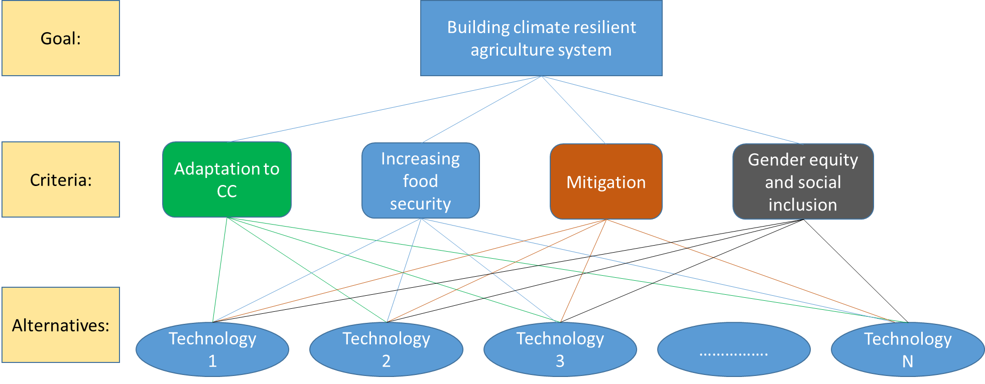

**Figure A1: The analytic hierarchy model for prioritizing CSA technologies**

Once the hierarchy was built, farmers systematically evaluated its various elements in first layer and second layer by comparing them to each other two at a time, with respect to their impact on an element above them in the hierarchy. For example, at the layer 1 (criteria), farmers were asked to rate which of the criteria e.g. ‘adaptation to climate change’ and ‘increasing food security’, is important to ‘build climate resilient agriculture system’. Similarly, at layer 2, farmers were asked to rate which of the technology (technology 1 or technology 2; technology 1 or technology 3 and so on until all possible pairwise comparison) is important for ‘adaptation to climate change’, ‘increasing food security’ and so on. A scale of 1-9 was used to record the degree of importance.

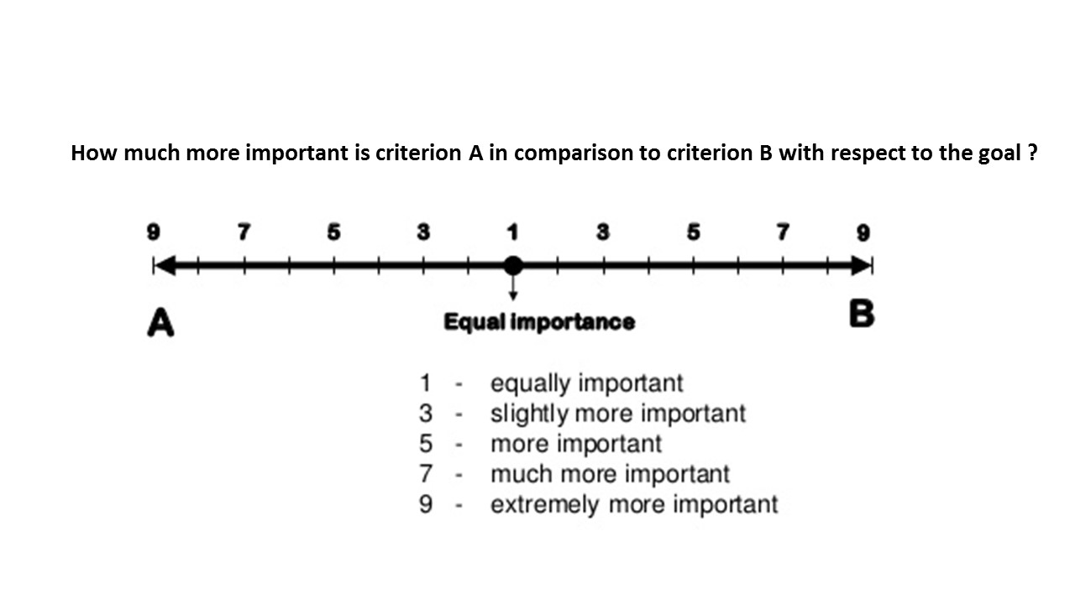

**Figure A2: AHP Scale used in pairwise comparisons of criteria**

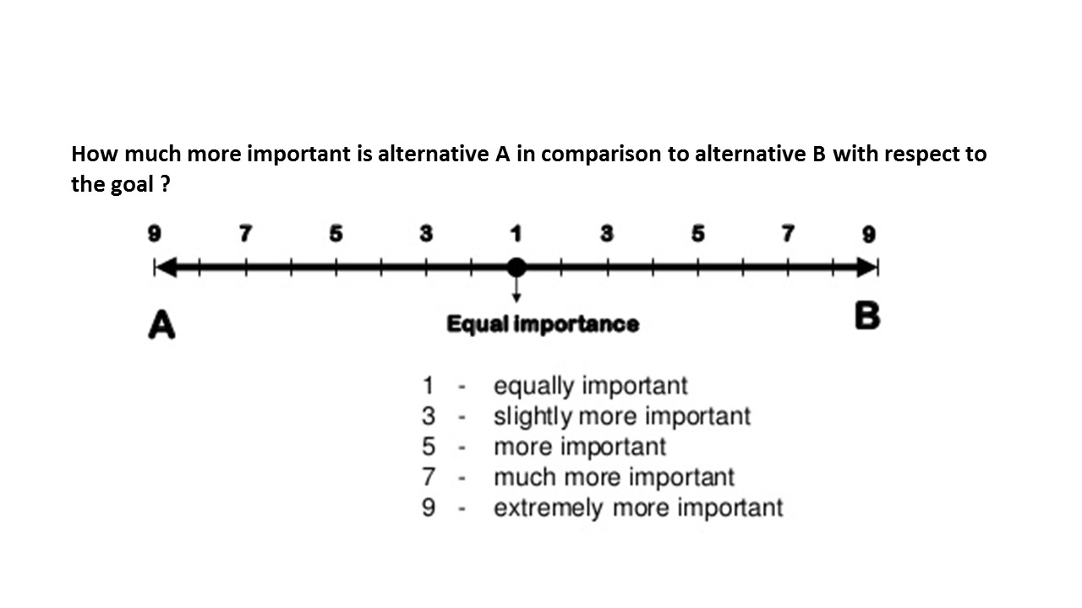

**Figure A3: AHP scale used in pairwise comparison of alternatives**

Farmers used their judgments about the elements' relative meaning and importance while providing their response. Altogether xx (xx female), xx (xx female) and xx (xx female) farmers in Kaski, Lamjung and Nawalparasi district provided their response in this survey. Only those farmers who have some knowledge about the technology, by either seeing in neighbors’ field, doing them in their own field or hearing and learning them from some other sources were asked to provide response.

Annex VII: AHP Questionnaire





















**Local Initiatives for Biodiversity,**

**Research and Development (LI-BIRD)**

**Contact:** POB 324, Pokhara, Kaski, Nepal

**Phone:** (++977) – 61 – 535357 / 526834

**Fax:** (++977) – 61 – 539956

**Email:** info@libird.org

**Website:** www.libird.org