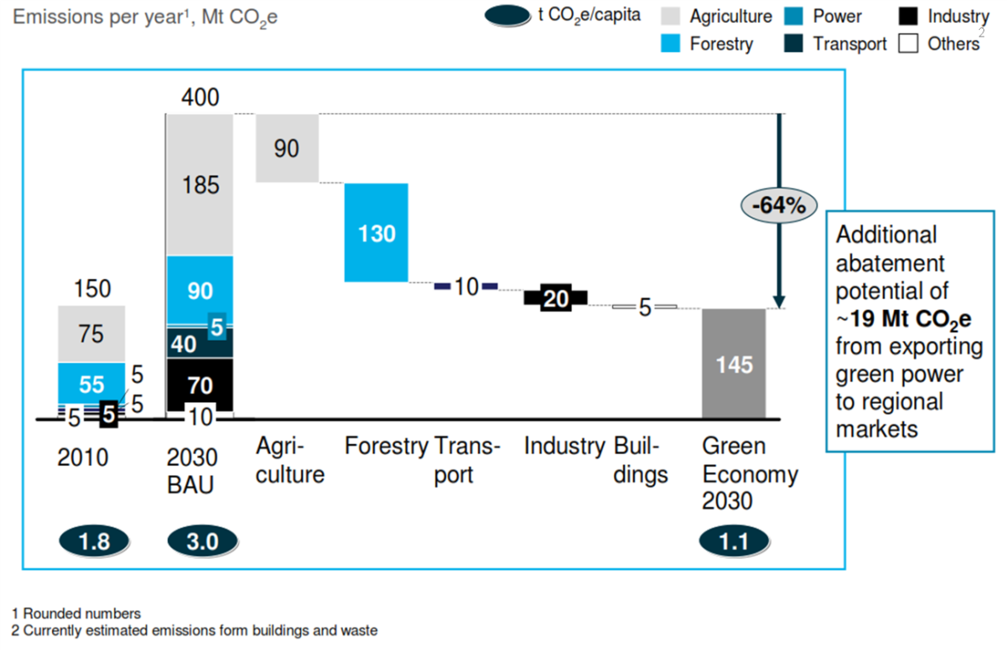

Sectoral abatement from business as usual trajectory

Source: Ethiopia-INDC-100615 http://www4.unfccc.int/submissions/indc/Submission%20Pages/submissions.aspx

