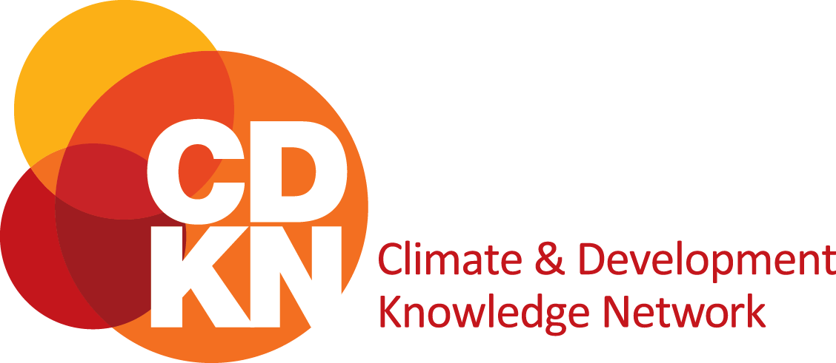

Application form: From knowledge to climate-resilient action in African countries
Please complete this application form and submit by no later than 23h59 Central Africa Time (CAT) on Sunday 07 May 2023. Should your application be chosen for proposal submission you will be notified before 31 May 2023.
We understand that French or English may not be everyone’s first language, so we will not penalise the incorrect use of grammar. Should you be uncertain regarding how to complete this application, please do check our frequently asked questions page, which will be regularly updated. In addition, we will host a webinar on the process on Thursday 13 April 2023, from 11h00 to 12h00 Central African Time (CAT). Please pre-register for the session here.
Remember to save this form by clicking on the save button.
1. Basic eligibility | Yes / no
Is the lead organisation based in Africa?
Does at least one organisation have an established presence in the locality in which the project is based?
Do you have at least one integral team member who is able to communicate reasonably in English or French, in both oral and written format, with the CDKN team?
Does this project contribute to locally-led climate-resilient action?
Does the project align with at least one of the CDKN themes?
Does the project commit to adhering to safeguarding and ethics principles?

Note: Only projects that meet the basic eligibility criteria will be considered for review.
2. Lead organisation details
Name of person leading the project
Role of project lead within the lead organisation
Email address
Secondary email address
Name of organisation
Type of organisation | e.g. community group, community-based organisation, cooperative, non-governmental organisation, international non-governmental organisation, sub-national/local government, academia, private sector, small- and medium-sized business, media organisation, social enterprise, etc.
Physical address
Please include city, country and postal code
Phone number
Including country code
Organisation website and/or other social media
Please choose one of the following: Is the organisation… | An African organisation  based in Africa, but with headquarters elsewhere  none of the above (describe)
Any comments

2.a Partner organisation details (please include details of each partner organisation below. More partner tables available at bottom of document if required)
Name of contact person
Role of person within organisation
Email address
Name of organisation
Type of organisation | e.g. community group, community-based organisation, cooperative, non-governmental organisation, international non-governmental organisation, sub-national/local government, academia, private sector, small- and medium-sized business, media organisation, social enterprise, etc.
Role of the organisation within the project
Physical address
Please include city, country and postal code
Phone number
Including country code
Organisation website and/or other social media
Please choose one of the following: Is the organisation… | An African organisation  based in Africa, but with headquarters elsewhere  neither of the above, but based in the global South
Any comments?

2.b Partner organisation details (please include details of all the additional partners. More partner tables available at bottom of document if required)
Name of contact person
Role of person within organisation

Email address
Name of organisation
Type of organisation | e.g. community group, community-based organisation, cooperative, non-governmental organisation, international non-governmental organisation, sub-national/local government, academia, private sector, small- and medium-sized business, media organisation, social enterprise, etc.
Role of the organisation within the project
Physical address
Please include city, country and postal code
Phone number
Including country code
Organisation website and/or other social media
Please choose one of the following: Is the organisation… | An African organisation  based in Africa, but with headquarters elsewhere  neither of the above, but based in the global South
Any comments

2.c Partner organisation details (please include details of all the additional partners. More partner tables available at bottom of document if required)
Name of contact person
Role of person within organisation
Email address
Name of organisation
Type of organisation | e.g. community group, community-based organisation, cooperative, non-governmental organisation, international non-governmental organisation, sub-national/local government, academia, private sector, small- and medium-sized business, media organisation, social enterprise, etc.
Role of the organisation within the project
Physical address
Please include city, country and postal code
Phone number
Including country code
Organisation website and/or other social media
Please choose one of the following: Is the organisation… | An African organisation  based in Africa, but with headquarters elsewhere  neither of the above, but based in the global South
Any comments?

3. Project summary
Project title
(Maximum 15 words)
Project objective/s
(Maximum 100 words)
CDKN themes: | Indicate which CDKN theme/s your project aligns with.  gender equity and social inclusion  finance for resilience  ecosystem-based approaches  enhancing climate literacy  empowering young people
Project duration | Projects must be completed by October 2026. Include the start and end date.
Where is the project’s geographic focus? | Country (ies).
 | Sub-national/provinces/wards.
Funding requested from CDKN (maximum US$ 150,000) | In US dollars; US$.
Parallel funding opportunities  (Maximum 100 words) | Please explain how this project does or can leverage other funding opportunities. Please include names and amounts where possible.

4. Project concept note
Project idea and methodology  (Maximum 500 words) | Please include:  - Why the project is necessary (this should include how the project is responding to local challenges, demands and/or opportunities)  - The project’s objectives and expected project impacts  - The proposed methods and activities that will be implemented in order to achieve the objectives
Furthering locally led climate-resilient action and mobilising local knowledge  (Maximum 500 words) | Please indicate:  - How your project supports local actors to lead the design and implementation of climate-resilient action  - How the project is linked and accountable to local community-based organisations or other local actors and is tailored to the local context  - How Indigenous and local knowledge will be mobilised, including by collaborating with different kinds of actors who hold different knowledge types to ensure that resilience action is shaped by local understanding and experience
Alignment with CDKN’s themes:  - gender equity and social inclusion  - finance for resilience  - ecosystem-based approaches  - enhancing climate literacy  - empowering young people  (Maximum 300 words) | Please indicate how your project supports one or more of CDKN’s themes.
Integration of gender equity and social inclusion considerations  (Maximum 300 words) | Please describe the gender equity and social inclusion considerations for your context and how they will be integrated throughout the design and implementation of this project.
Sustainability and/or continuation of impact  (Maximum 400 words) | Please indicate sustainability plans for your project after the CDKN grant ends to ensure that project impact and successes remain.
Safeguarding and ensuring no harm done as a result of project activities  (Maximum 300 words) | Please indicate the risks your project poses to the project implementers and the communities in which the project is being implemented and how you will address this.  Please describe how the project’s team will include or has included safeguarding measures and ethics procedures within the implementing organisation or in the project design.

5. Team composition and leadership
African leadership  (Maximum 200 words) | Please describe in what way the project is African led? This includes partnerships and collaborations between African-based organisations and nationals.
Role of the lead organisation within the project | Please describe the role of the lead organisation in the project.
Team and leadership diversity  (Maximum 200 words) | Please describe the gender and social diversity of the project team members. Please describe how marginalised groups are included in the project team and leadership.
Team composition
Name of team member |  | Organisation | Title and role in project

7: Budget (US$)
 | Year 1 | Year 2 | Year 3 | Total | Proportion % | Notes
Partner 1 [insert organisation name] personnel fees |  |  |  |  |  | Please include no of persons  Please include the range of the rates
Partner 2 [insert organisation name] personnel fees |  |  |  |  |  | Please include no of persons  Please include the range of the rates
Partner 3 [insert organisation name] personnel fees |  |  |  |  |  | Please include no of persons  Please include the range of the rates
Outsourced consultants and service providers |  |  |  |  |  | Please include no of persons  Please include the range of the rates
Travel
Project activities |  |  |  |  |  | Please include details of the type of costs, e.g., workshops, subsidies, subscriptions, etc.
Subtotal |  |  |  |  | 100%
Indirect costs (maximum of 13% of direct costs)
Total (not greater than US$ 150,000)

8: Declaration
Please include the names and organisations of the people who contributed to this submission: | Name | Organisation
Person 1
Person 2
Person 3
Person 4 etc.
Declaration by project lead: I declare that the above information is accurate to the best of my knowledge.
Name
Signature
Date

2.d Partner organisation details (please include details of all the additional partners. Copy and paste the table if necessary)
Name of contact person
Role of person within organisation
Email address
Name of organisation
Type of organisation | e.g. community group, community-based organisation, cooperative, non-governmental organisation, international non-governmental organisation, sub-national/local government, academia, private sector, small- and medium-sized business, media organisation, social enterprise, etc.
Role of the organisation within the project
Physical address
Please include city, country and postal code
Phone number
Including country code
Organisation website and/or other social media
Please choose one of the following: Is the organisation… | An African organisation  based in Africa, but with headquarters elsewhere  neither of the above, but based in the global South
Any comments?

Only the lead organisation details should be included here. Separate tables for each additional partner are included below.
CDKN recognises a diversity of knowledge types need to be engaged for sustainable and equitable action on the ground: local knowledge developed by people and communities specific to the places where they live; Indigenous and traditional knowledge comprising the understandings, skills and philosophies developed by societies with long histories of interaction with their natural surroundings; experiential, applied knowledge held by practitioners and those working in the field based on their practical experience; and scientific knowledge generally provided by academic researchers.
Insert more rows as needed
Please add additional rows for additional partners as needed.
Please add additional rows for more project activities expenses as needed.
Insert more rows as needed

